

**Department of CSE**

**Course name: Cybersecurity, Law, and Ethics**

**Course Code: CSE487**

**Section:**

**Group: 04**

**Mini Project - 1**

**Securing a networked system with Public Key Infrastructure Implementing**

**Transport Layer Security on HTTP for** [**https://connection**](https://connection/)

**Submitted By:**

| **Student’s Name** | **Student’s ID** |
| --- | --- |
|  |  |
| Lamia Akter | 2021-3-60-147 |
|  |  |
| Halima Sadia | 2021-3-60-280 |
| Afsara Tasnim Biva | 2022-1-60-396 |
| Nusrat Marium | 2022-1-60-390 |
|  |  |

**Submitted To:**

**Dr. Md. Hasanul Ferdaus**

**Assistant Professor**

**Department of Computer Science & Engineering**

**Video Link:** [**Project 1**](https://drive.google.com/file/d/1qkBG6EDe6Ai9N9-llVF6DK6hRel8ntn9/view?usp=sharing)

https://drive.google.com/drive/folders/1HFQC5cbP3ghHIOVoLItnm31y6AXwxztp

**OBJECTIVE**

**Implementing Transport Layer Security on HTTP**

**Introduction**

Securing online communication is essential to protect sensitive data, ensure transaction authenticity, and build user trust in the digital age. Public Key Infrastructure (PKI) and Transport Layer Security (TLS) are foundational technologies that enable secure communication over the Internet. This report explores the implementation of these technologies to establish a robust security framework for websites.

**Public Key Infrastructure (PKI)** is a security framework that uses cryptographic keys and digital certificates to provide essential services such as authentication, encryption, and digital signatures. It ensures secure communication and data integrity while preventing unauthorized access. Key components of PKI include:

* **Certificates**: Digital documents issued by a trusted Certificate Authority (CA) to verify the authenticity of public keys.
* **Certificate Authority (CA)**: A trusted entity that issues and manages digital certificates.
* **Registration Authority (RA)**: Verifies the identity of entities before certificates are issued.

PKI plays a crucial role in ensuring security, trust, and integrity across networked systems. It authenticates users, prevents impersonation attacks, guarantees data integrity during transmission, and provides non-repudiation through digital signatures. These capabilities make PKI a cornerstone for establishing secure online communication.

**Transport Layer Security (TLS)** is the successor to Secure Sockets Layer (SSL) and encrypts data transmitted between web servers and clients. TLS ensures the safe transfer of sensitive information, such as personal data and payment details, while preventing eavesdropping, manipulation, and impersonation. TLS, combined with PKI for certificate management, underpins HTTPS—a secure protocol essential for e-commerce, online banking, and other web services handling sensitive information.

**Project Description**

The project focuses on implementing SSL/TLS certificates and configuring a secure infrastructure to protect user data, verify site ownership, and establish trust with users. The goal is to enable a secure padlock icon for the website, [www.verysecureserver.com](http://www.verysecureserver.com), and ensure robust protection against unauthorized access.

Key tasks included:

1. Setting up Certificate Authorities (CAs) and generating digital certificates for root, intermediate (sub-CA), and server entities.
2. Configuring TLS on Ubuntu and Windows servers to create encrypted communication channels.
3. Validating website security through the proper installation and configuration of certificates.
4. Implementing a firewall to prevent unauthorized access.
5. Configuring DNS and SSL/TLS certificates for seamless and secure access.

This guide outlines the detailed steps taken to set up and validate the secure connection, with a focus on Ubuntu 18.04.

**Objective**

The primary objective is to enhance website security by implementing PKI and TLS. Specific goals include:

* Establishing secure communication channels to protect data during transmission.
* Authenticating users and devices through digital certificates.
* Ensuring data integrity and non-repudiation using cryptographic techniques.
* Strealinux-headers-generic
* gement through centralized certificate lifecycle management.
* Educating users on best practices for key management and security awareness.

Through this project, we aim to guarantee data confidentiality, integrity, and trust among all network participants.

**Workflow**

The project workflow involves several critical steps to ensure the successful implementation of PKI and TLS:

1. **Setting Up the Certificate Authority (CA) Infrastructure**
   * Created a directory structure for root CA, sub-CA, and server certificates.
   * Generated private keys and certificate signing requests (CSRs) for each entity.
   * Configured root and sub-CA certificates using OpenSSL.
2. **Configuring Server Certificates**
   * Generated server keys and CSRs.
   * Signed server certificates with the sub-CA to establish a certificate chain.
   * Combined certificates into a chained certificate for simplified deployment.
3. **TLS Configuration on Web Servers**
   * Configured Apache server on Ubuntu to enable HTTPS.
   * Edited the httpd-ssl.conf file to point to the correct certificate and key files.
   * Set up automatic HTTP to HTTPS redirection for secure browsing.
4. **Testing and Validation**
   * Imported root and sub-CA certificates into browsers for trust verification.
   * Verified the padlock icon and certificate chain on the website.
   * Conducted vulnerability scans to ensure the TLS configuration met security standards.
5. **Firewall and DNS Configuration**
   * Implemented firewall rules to block unauthorized access.
   * Configured DNS settings to allow seamless access to the secure site.

**Key Features of PKI Implementation**

1. **Enhanced Authentication**: Replaced traditional username/password systems with digital certificates for robust identity verification.
2. **Secure Communication Channels**: Enabled encrypted data transmission to safeguard sensitive information.
3. **Data Integrity and Non-Repudiation**: Utilized digital signatures to ensure data authenticity and prevent tampering.
4. **Centralized Security Management**: Simplified certificate lifecycle management for improved security oversight.
5. **User Training and Awareness**: Educated users on PKI principles and key management practices to foster a culture of security.

Pre-Installation Files

1. sudo apt update
2. sudo apt install tree
3. sudo apt install net-tools
4. sudo apt install curl
5. sudo apt install bind9
6. sudo apt install vim
7. sudo apt install build-essential dkms linux-headers-generic

But in my version all are already installed

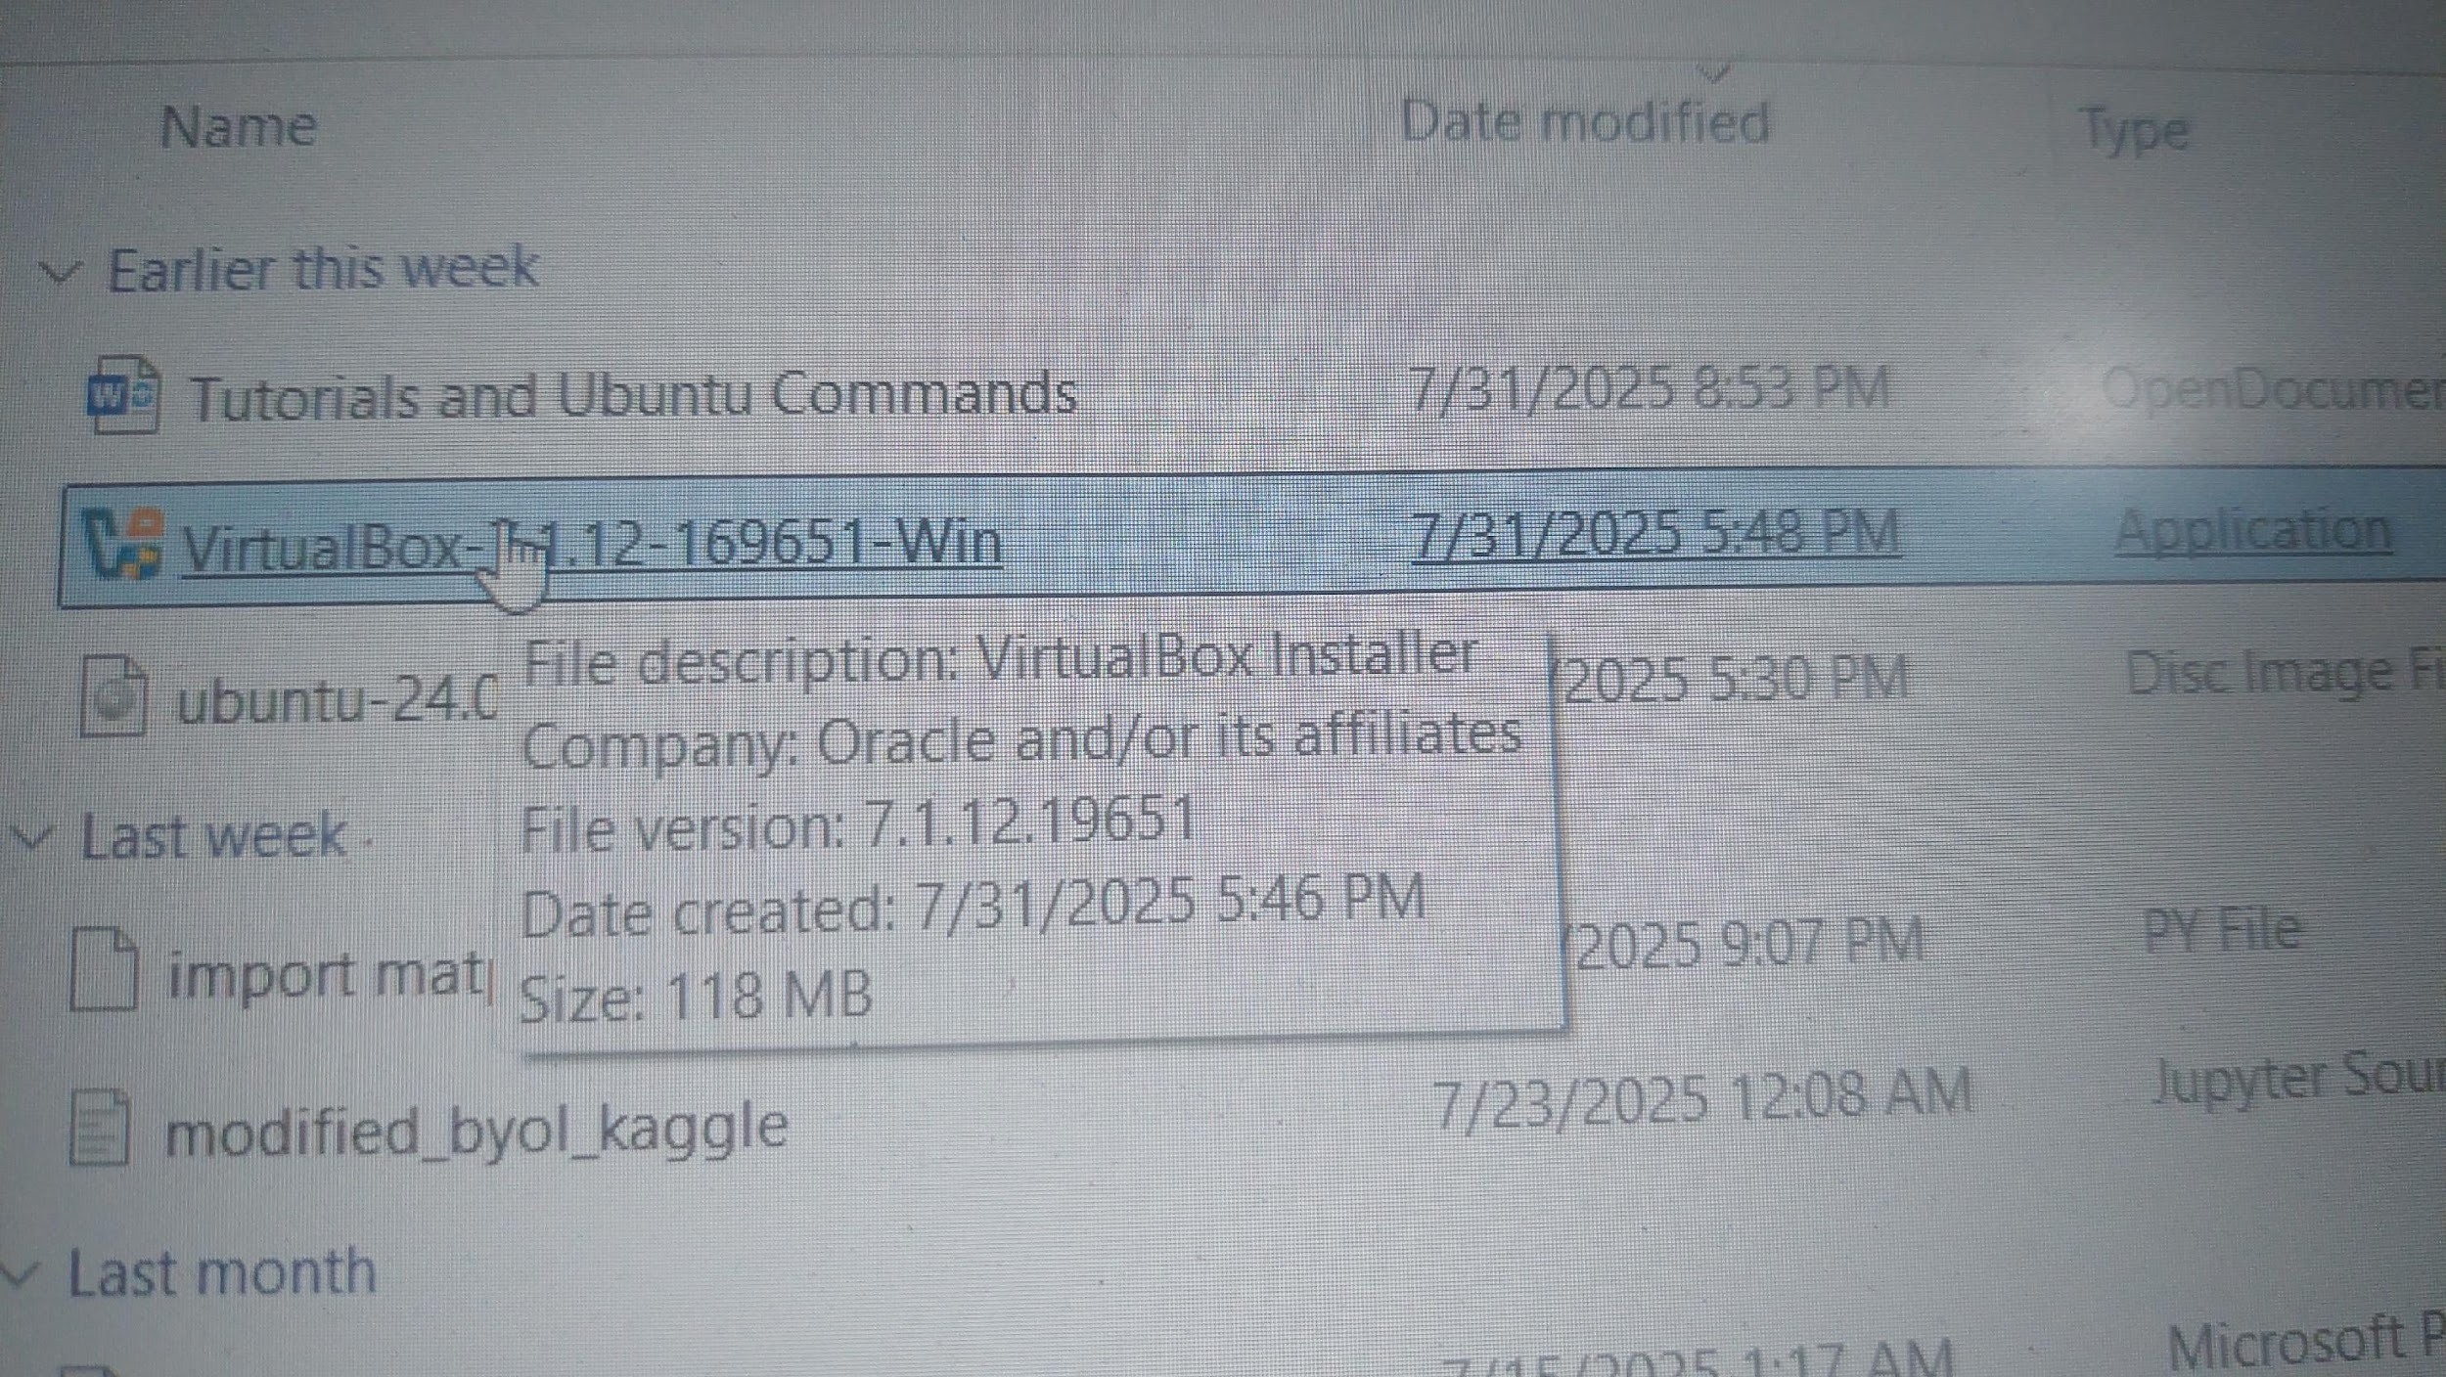

Configuration of Certification Authority and Implementation of Transport

Layer Security over HTTP

On linux terminal inside VirtualBox the following commands need to be given to generate Transport Layer

Security over HTTP:

1. Preparing the environment

Moving to the root using

---------------------------

* sudo -i

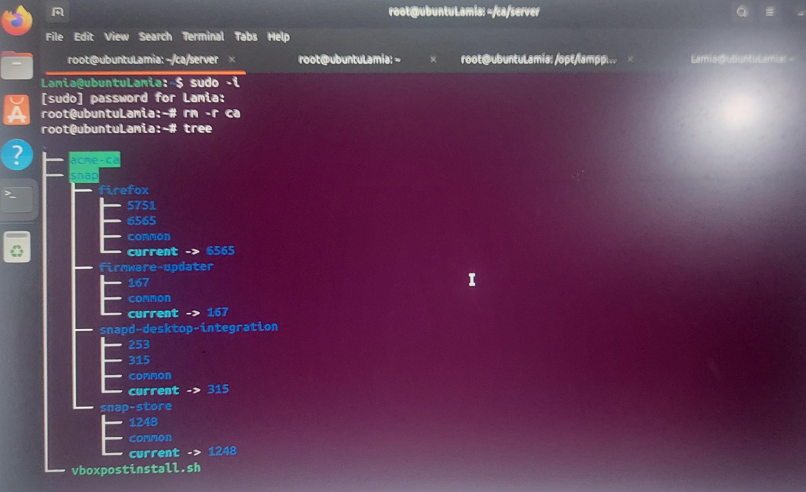

* Creating directory: mkdir -p ca/{root-ca,sub-ca,server}/{private,certs,newcerts,crl,csr}

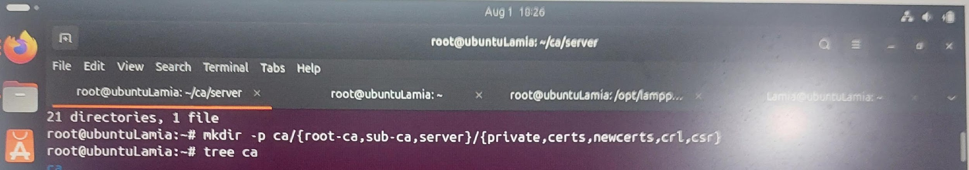

* See if the folders are created successfully: tree ca

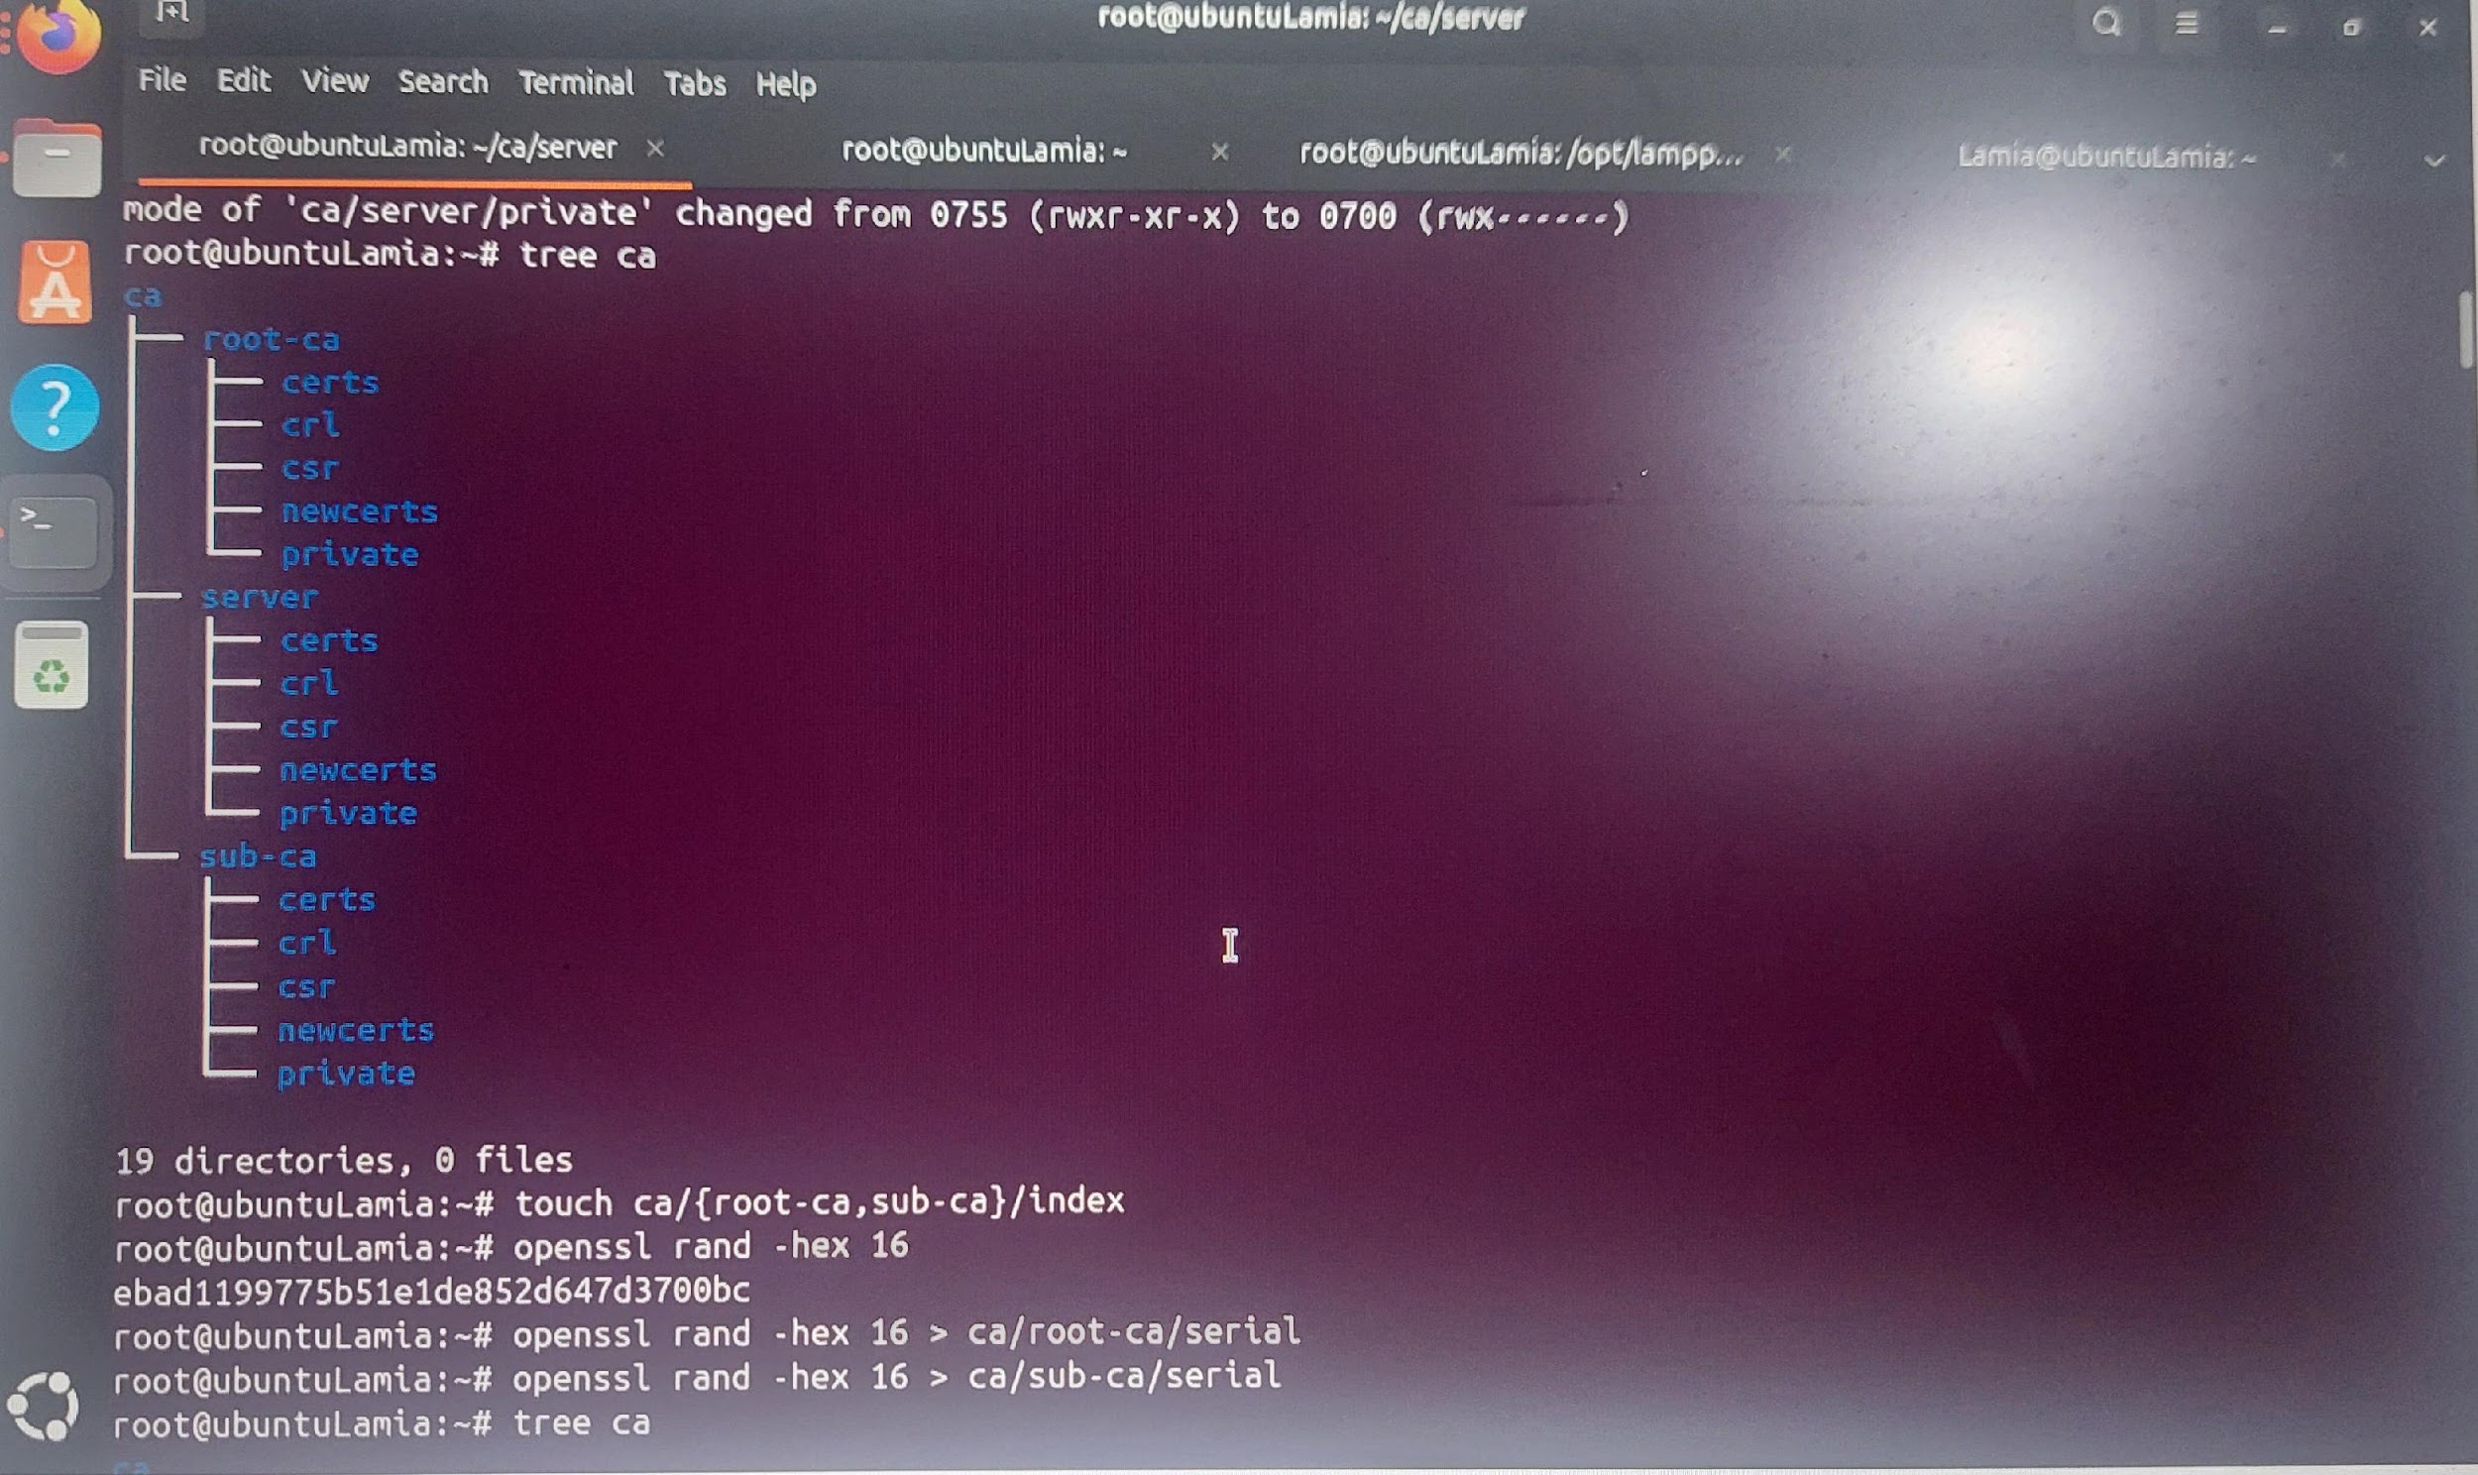

* Changing the root of ca and sub ca private folder: chmod -v 700 ca/{root-ca,sub-ca,server}/private

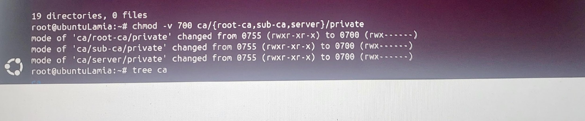

* Creating file index in both root ca and sub ca: touch ca/{root-ca,sub-ca}/index

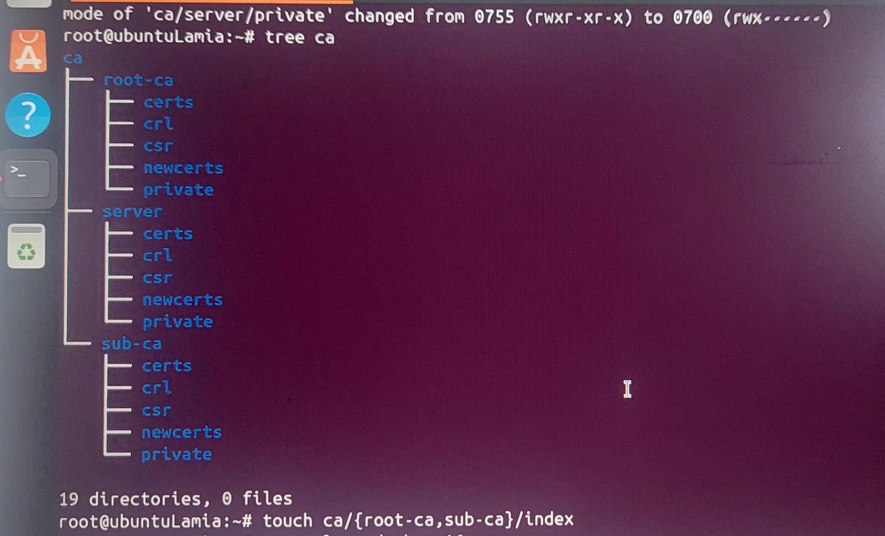

* Generating hexadecimal random number of 16 character : openssl rand -hex 16
* writing serial number of root ca: openssl rand -hex 16 > ca/root-ca/serial
* writing serial number of sub ca: openssl rand -hex 16 > ca/sub-ca/serial

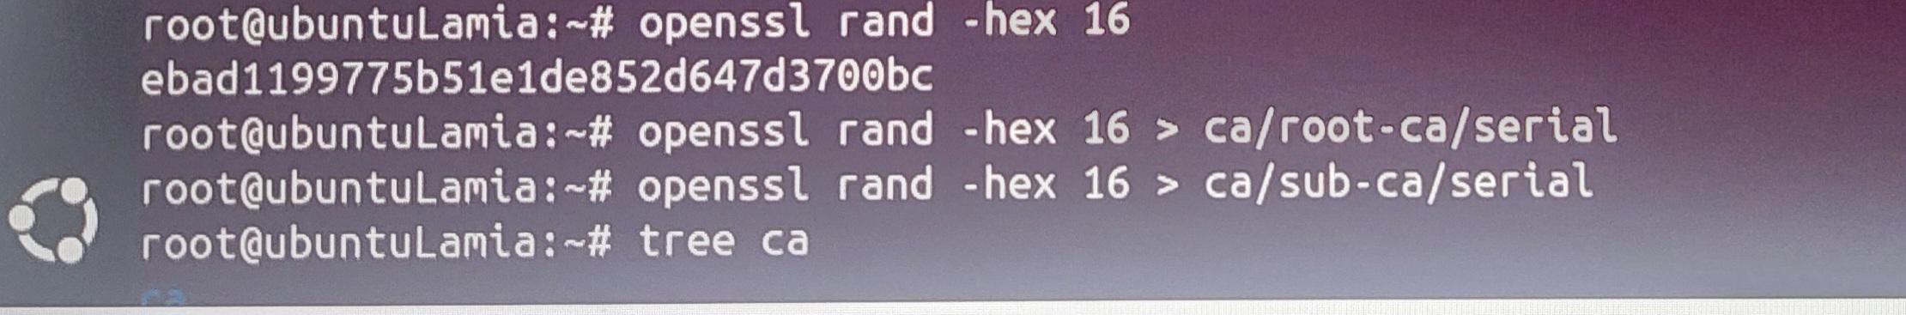

* See the ca tree: tree ca

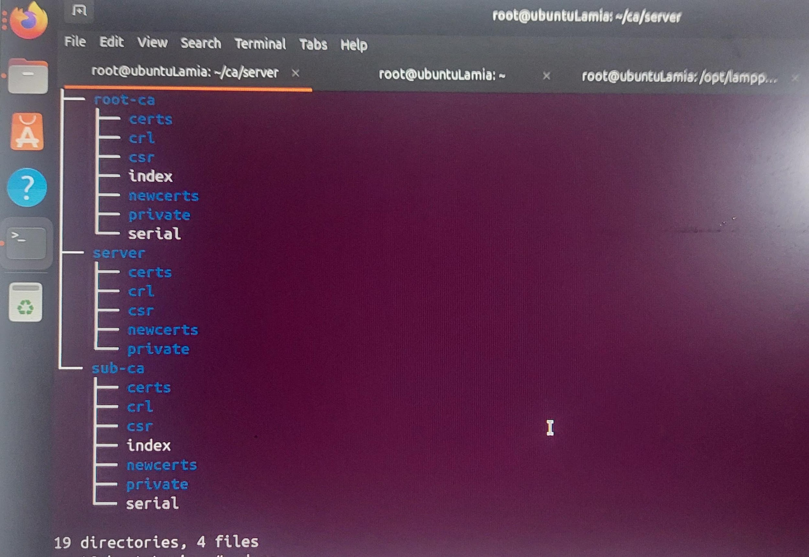

* moving to ca directory: cd ca

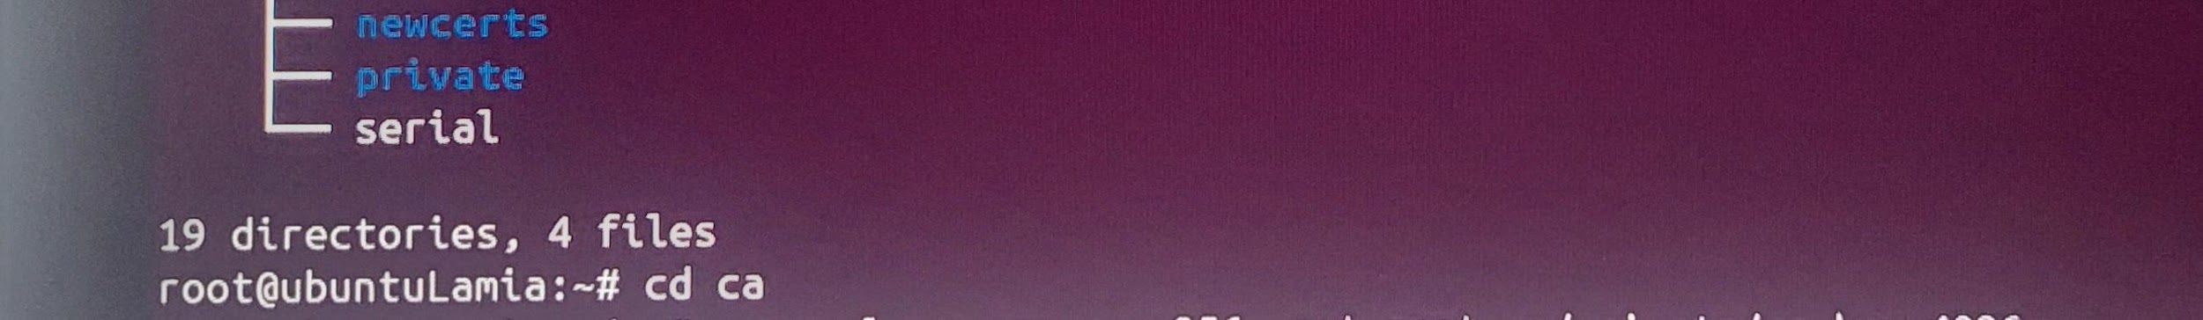

2. Generating private key for root ca, sub ca and server

* Public key for rootCA: openssl genrsa -aes256 -out root-ca/private/ca.key 4096

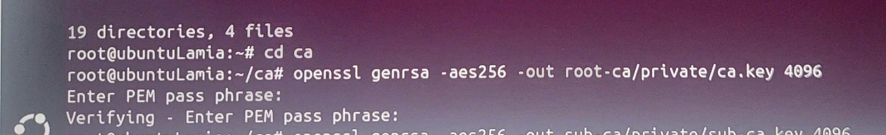

* Public key for subCA: openssl genrsa -aes256 -out sub-ca/private/sub-ca.key 4096

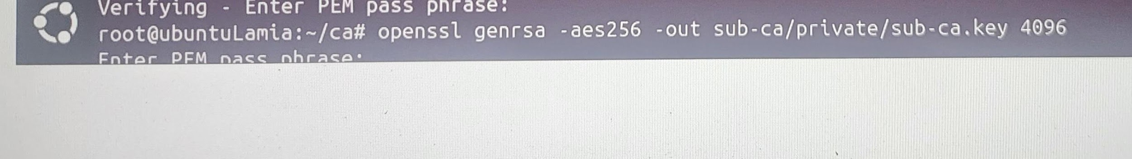

* Public key for server: openssl genrsa -out server/private/server.key 2048

* reviewing the change: tree

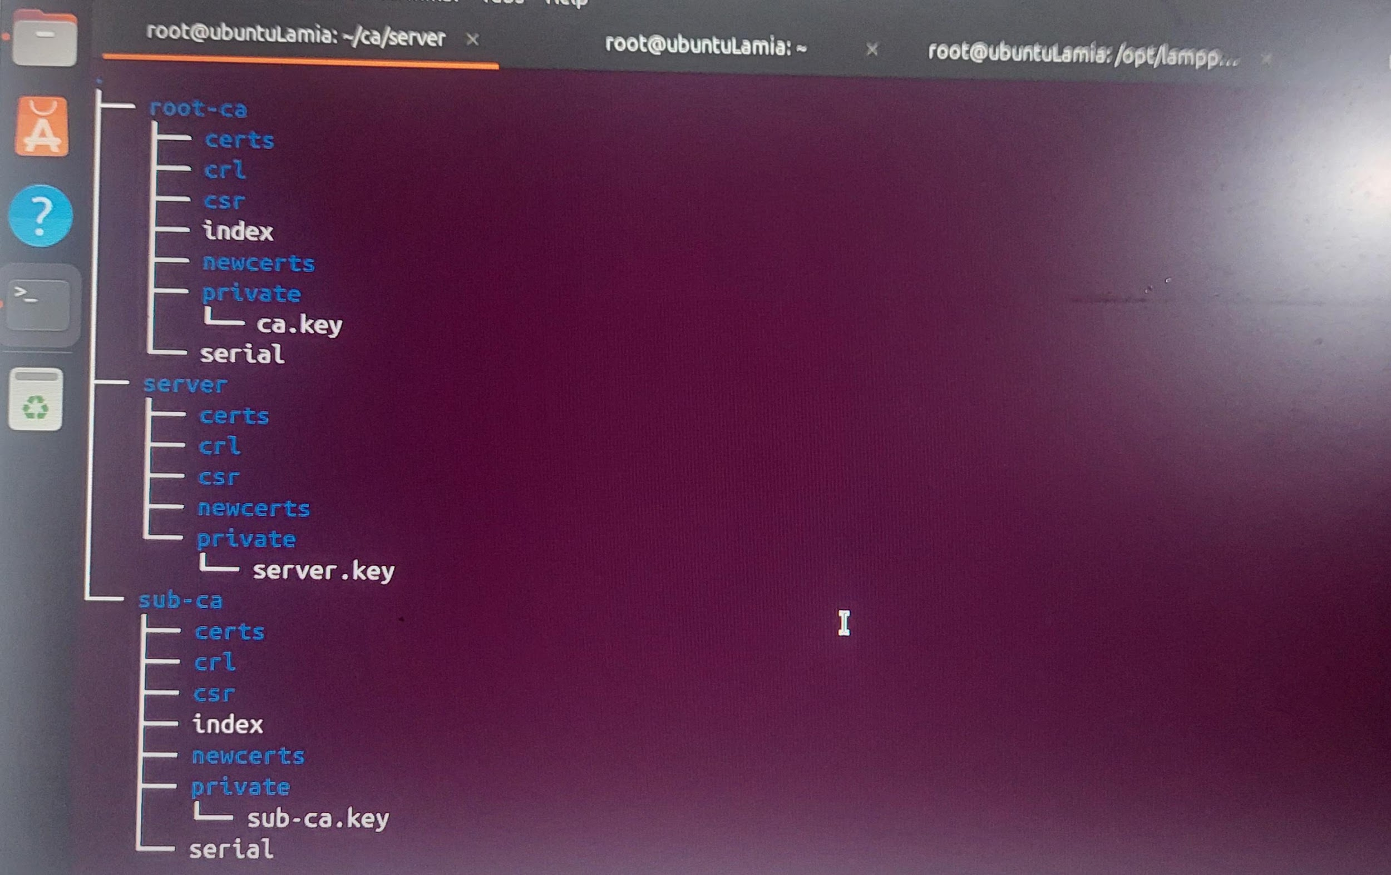

1. Generating certificates

Root-CA

* Creating root ca.config: gedit root-ca/root-ca.conf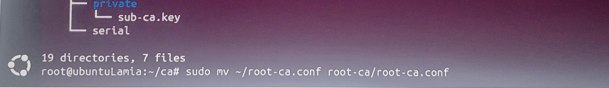

Inserting the code from the link into the root-ca.config

[link or text]

* Moving inside root-ca: cd root-ca

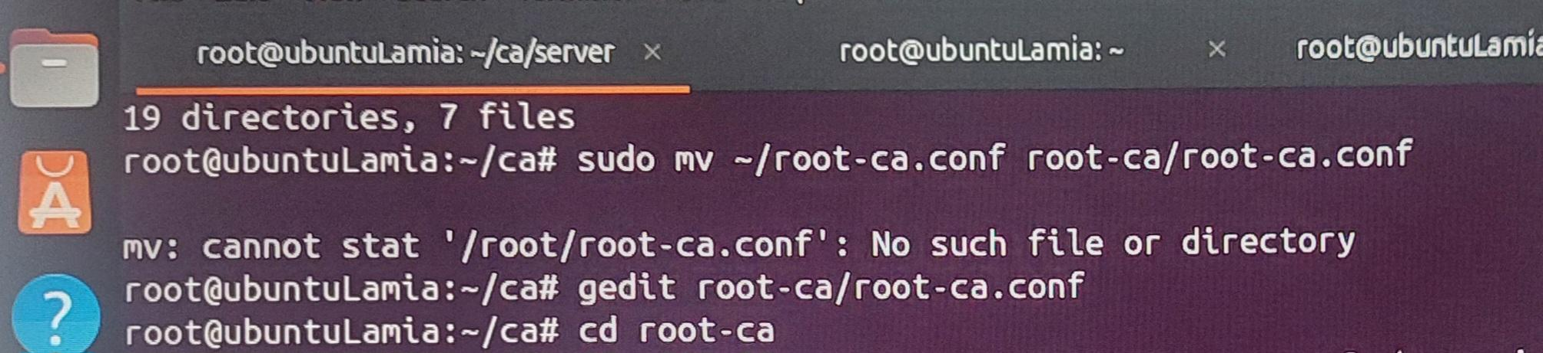

* Generating root ca certificate: openssl req -config root-ca.conf -key private/ca.key -new -x509 -days 7305 -sha256 -extensions v3_ca -out certs/ca.crt

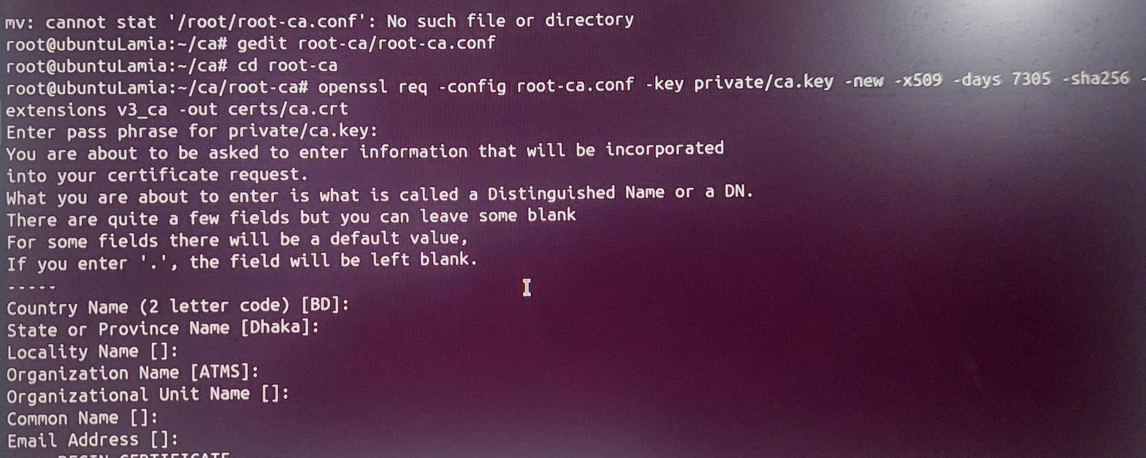

* Ensuring that the certificate has been created properly: openssl x509 -noout -in certs/ca.crt -text

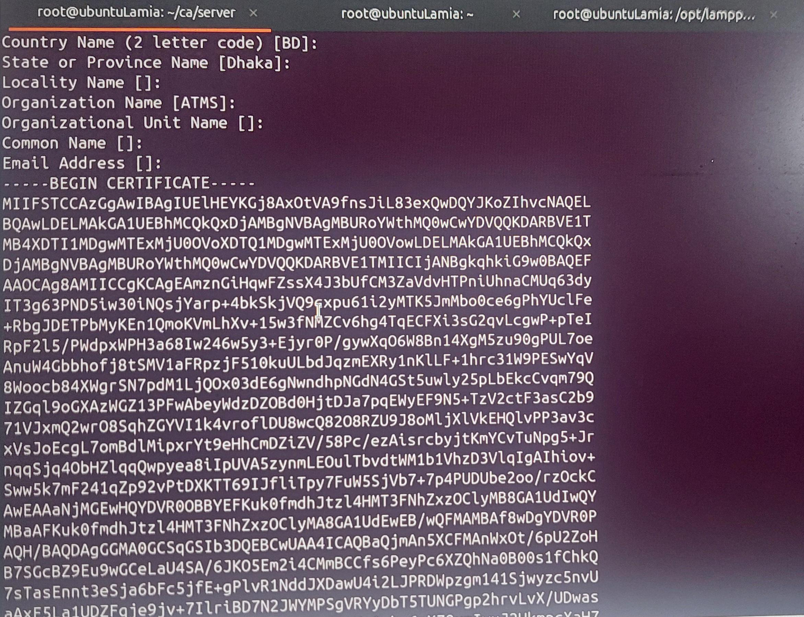

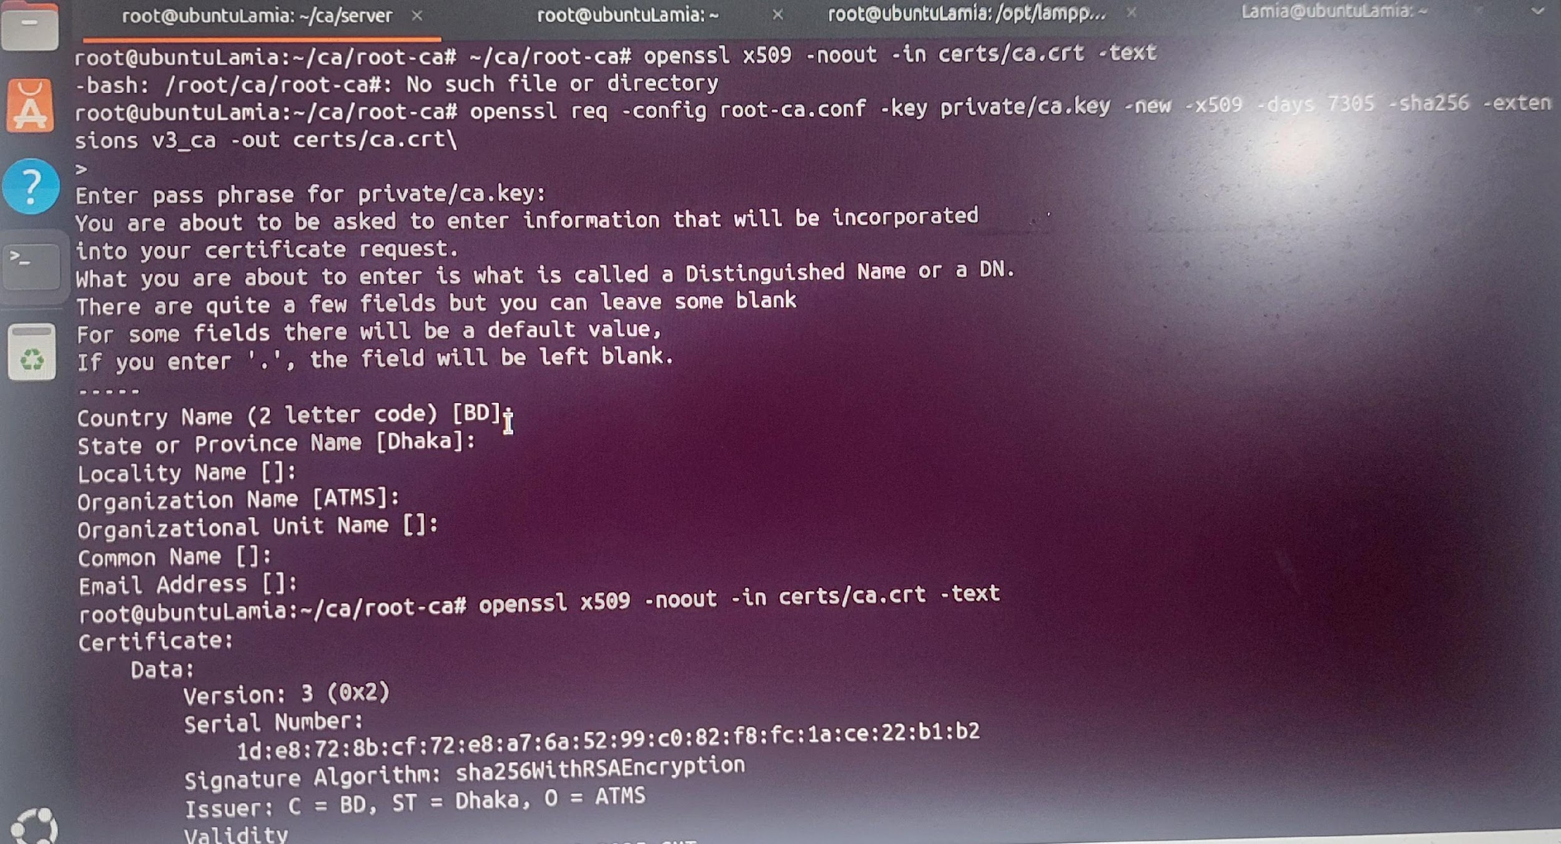

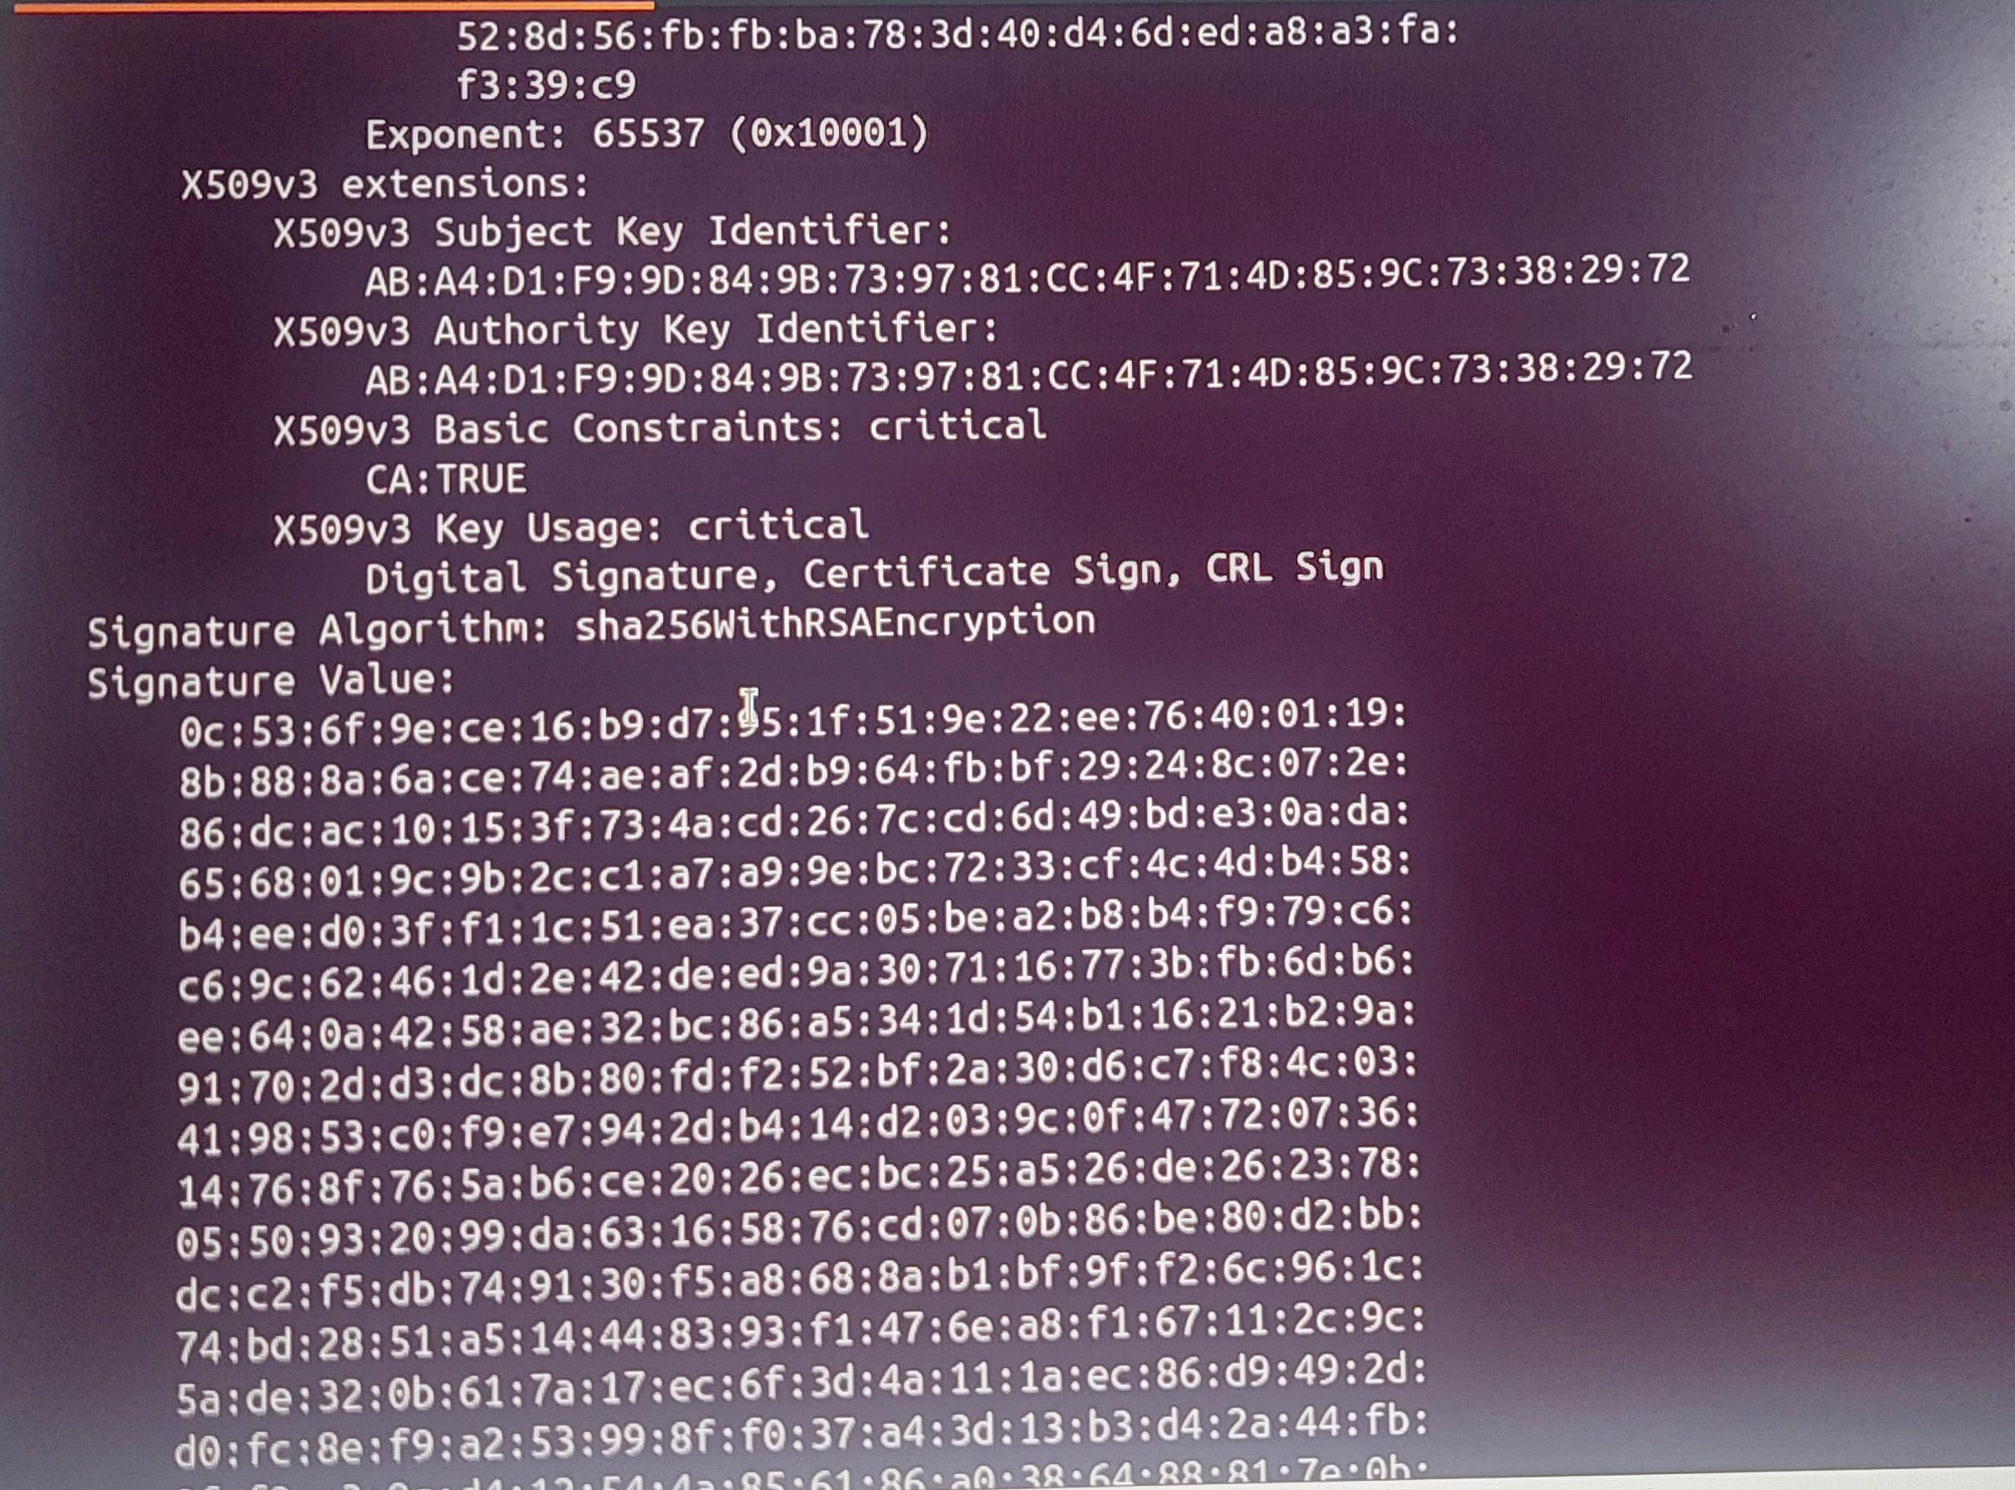

* Moving a step back and then to sub-ca: cd ../sub-ca and

Sub-CA

* Creating sub-ca.config: gedit sub-ca

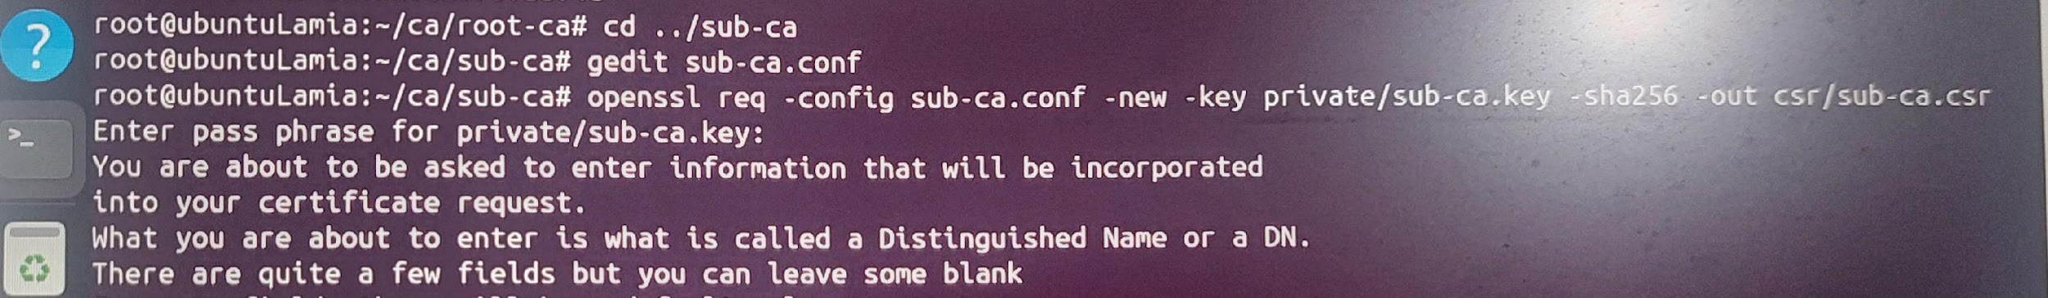

Inserting the code into sub-ca.config file

[link or text]

* Requesting for sub ca certificate signing request: openssl req -config sub-ca.conf -new -key private/sub-ca.key -sha256 -out csr/sub-ca.csr

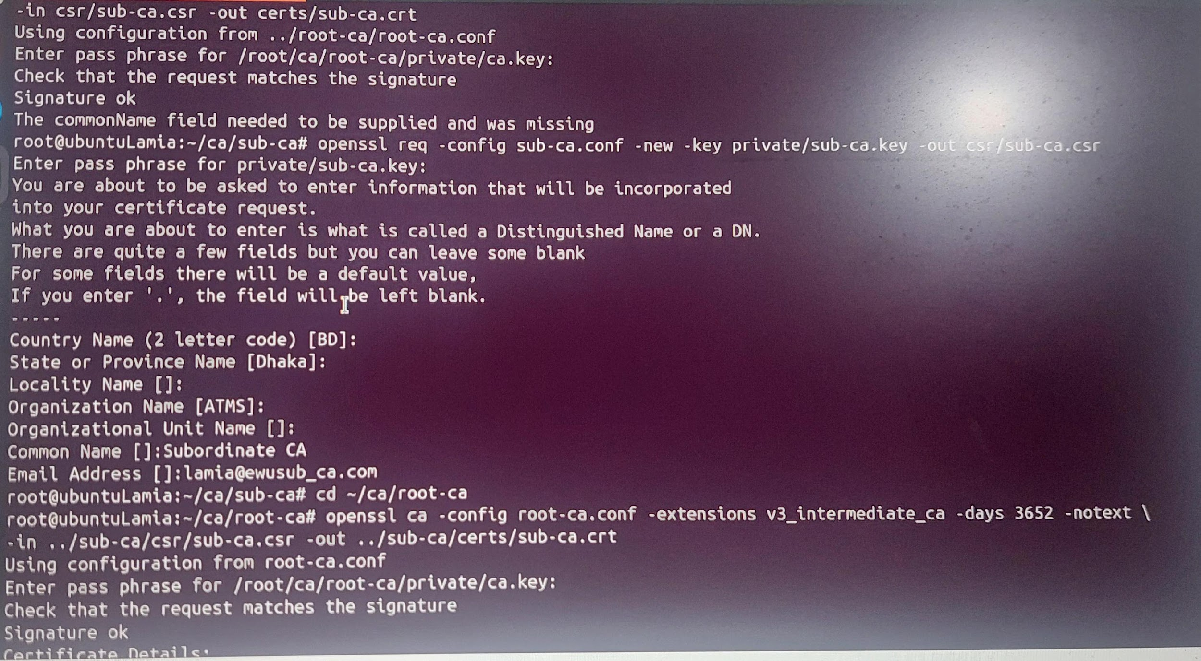

* moving to the previous folder: cd -
* Signing the request of sub ca by root ca: openssl ca -config root-ca.conf -extensions v3_intermediate_ca -days 3652 -notext -in ../sub-ca/csr/sub-ca.csr -out ../sub-ca/certs/sub-ca.crt

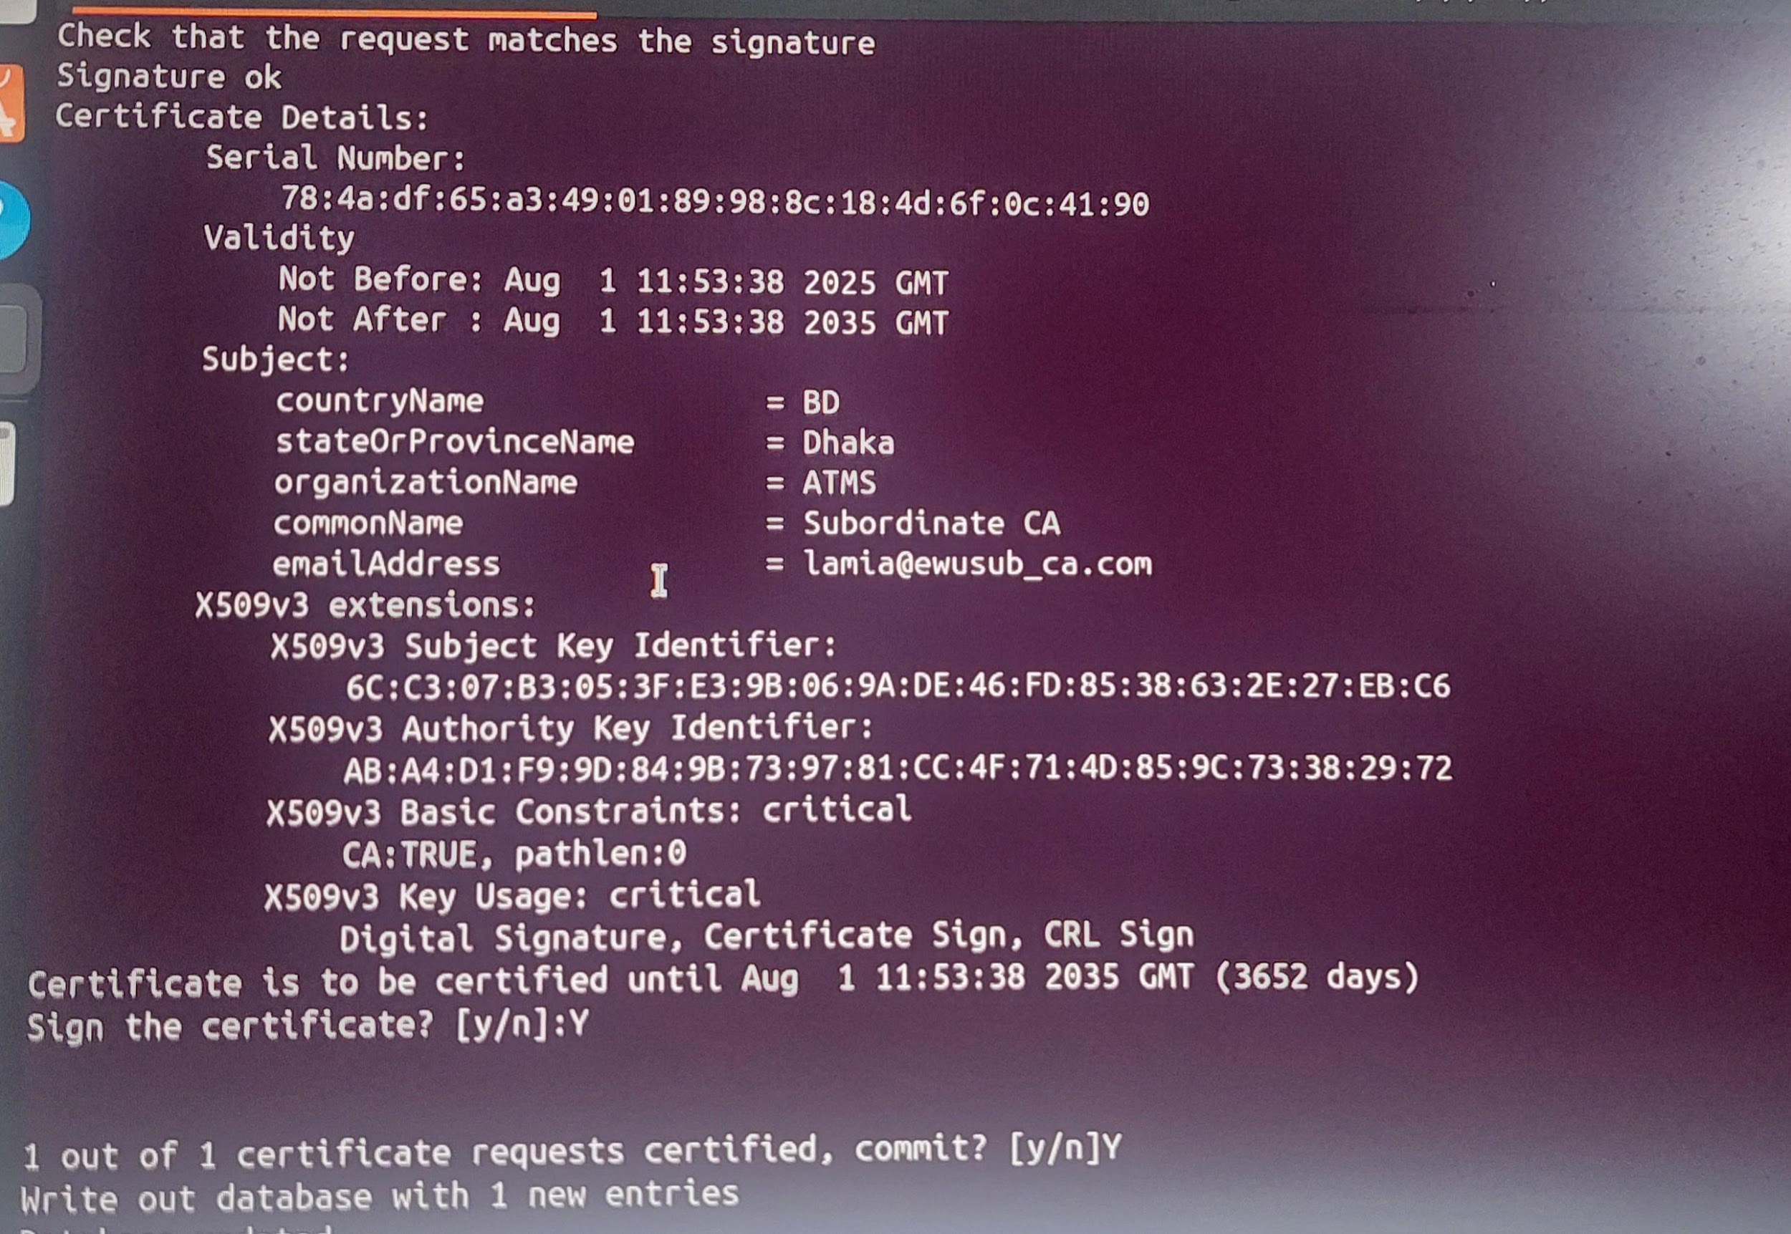

* See directory: tree

→.pem file has been generated

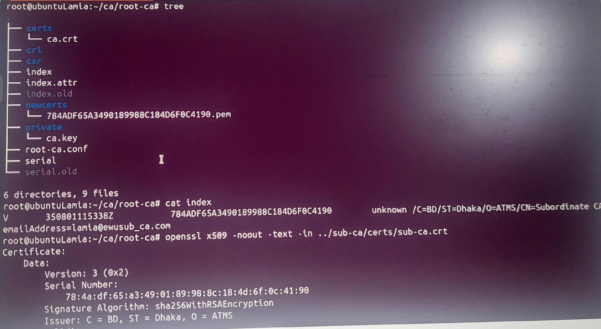

* See the signing: cat index
* Root ca signed sub ca details: openssl x509 -noout -text -in ../sub-ca/certs/sub-ca.crt

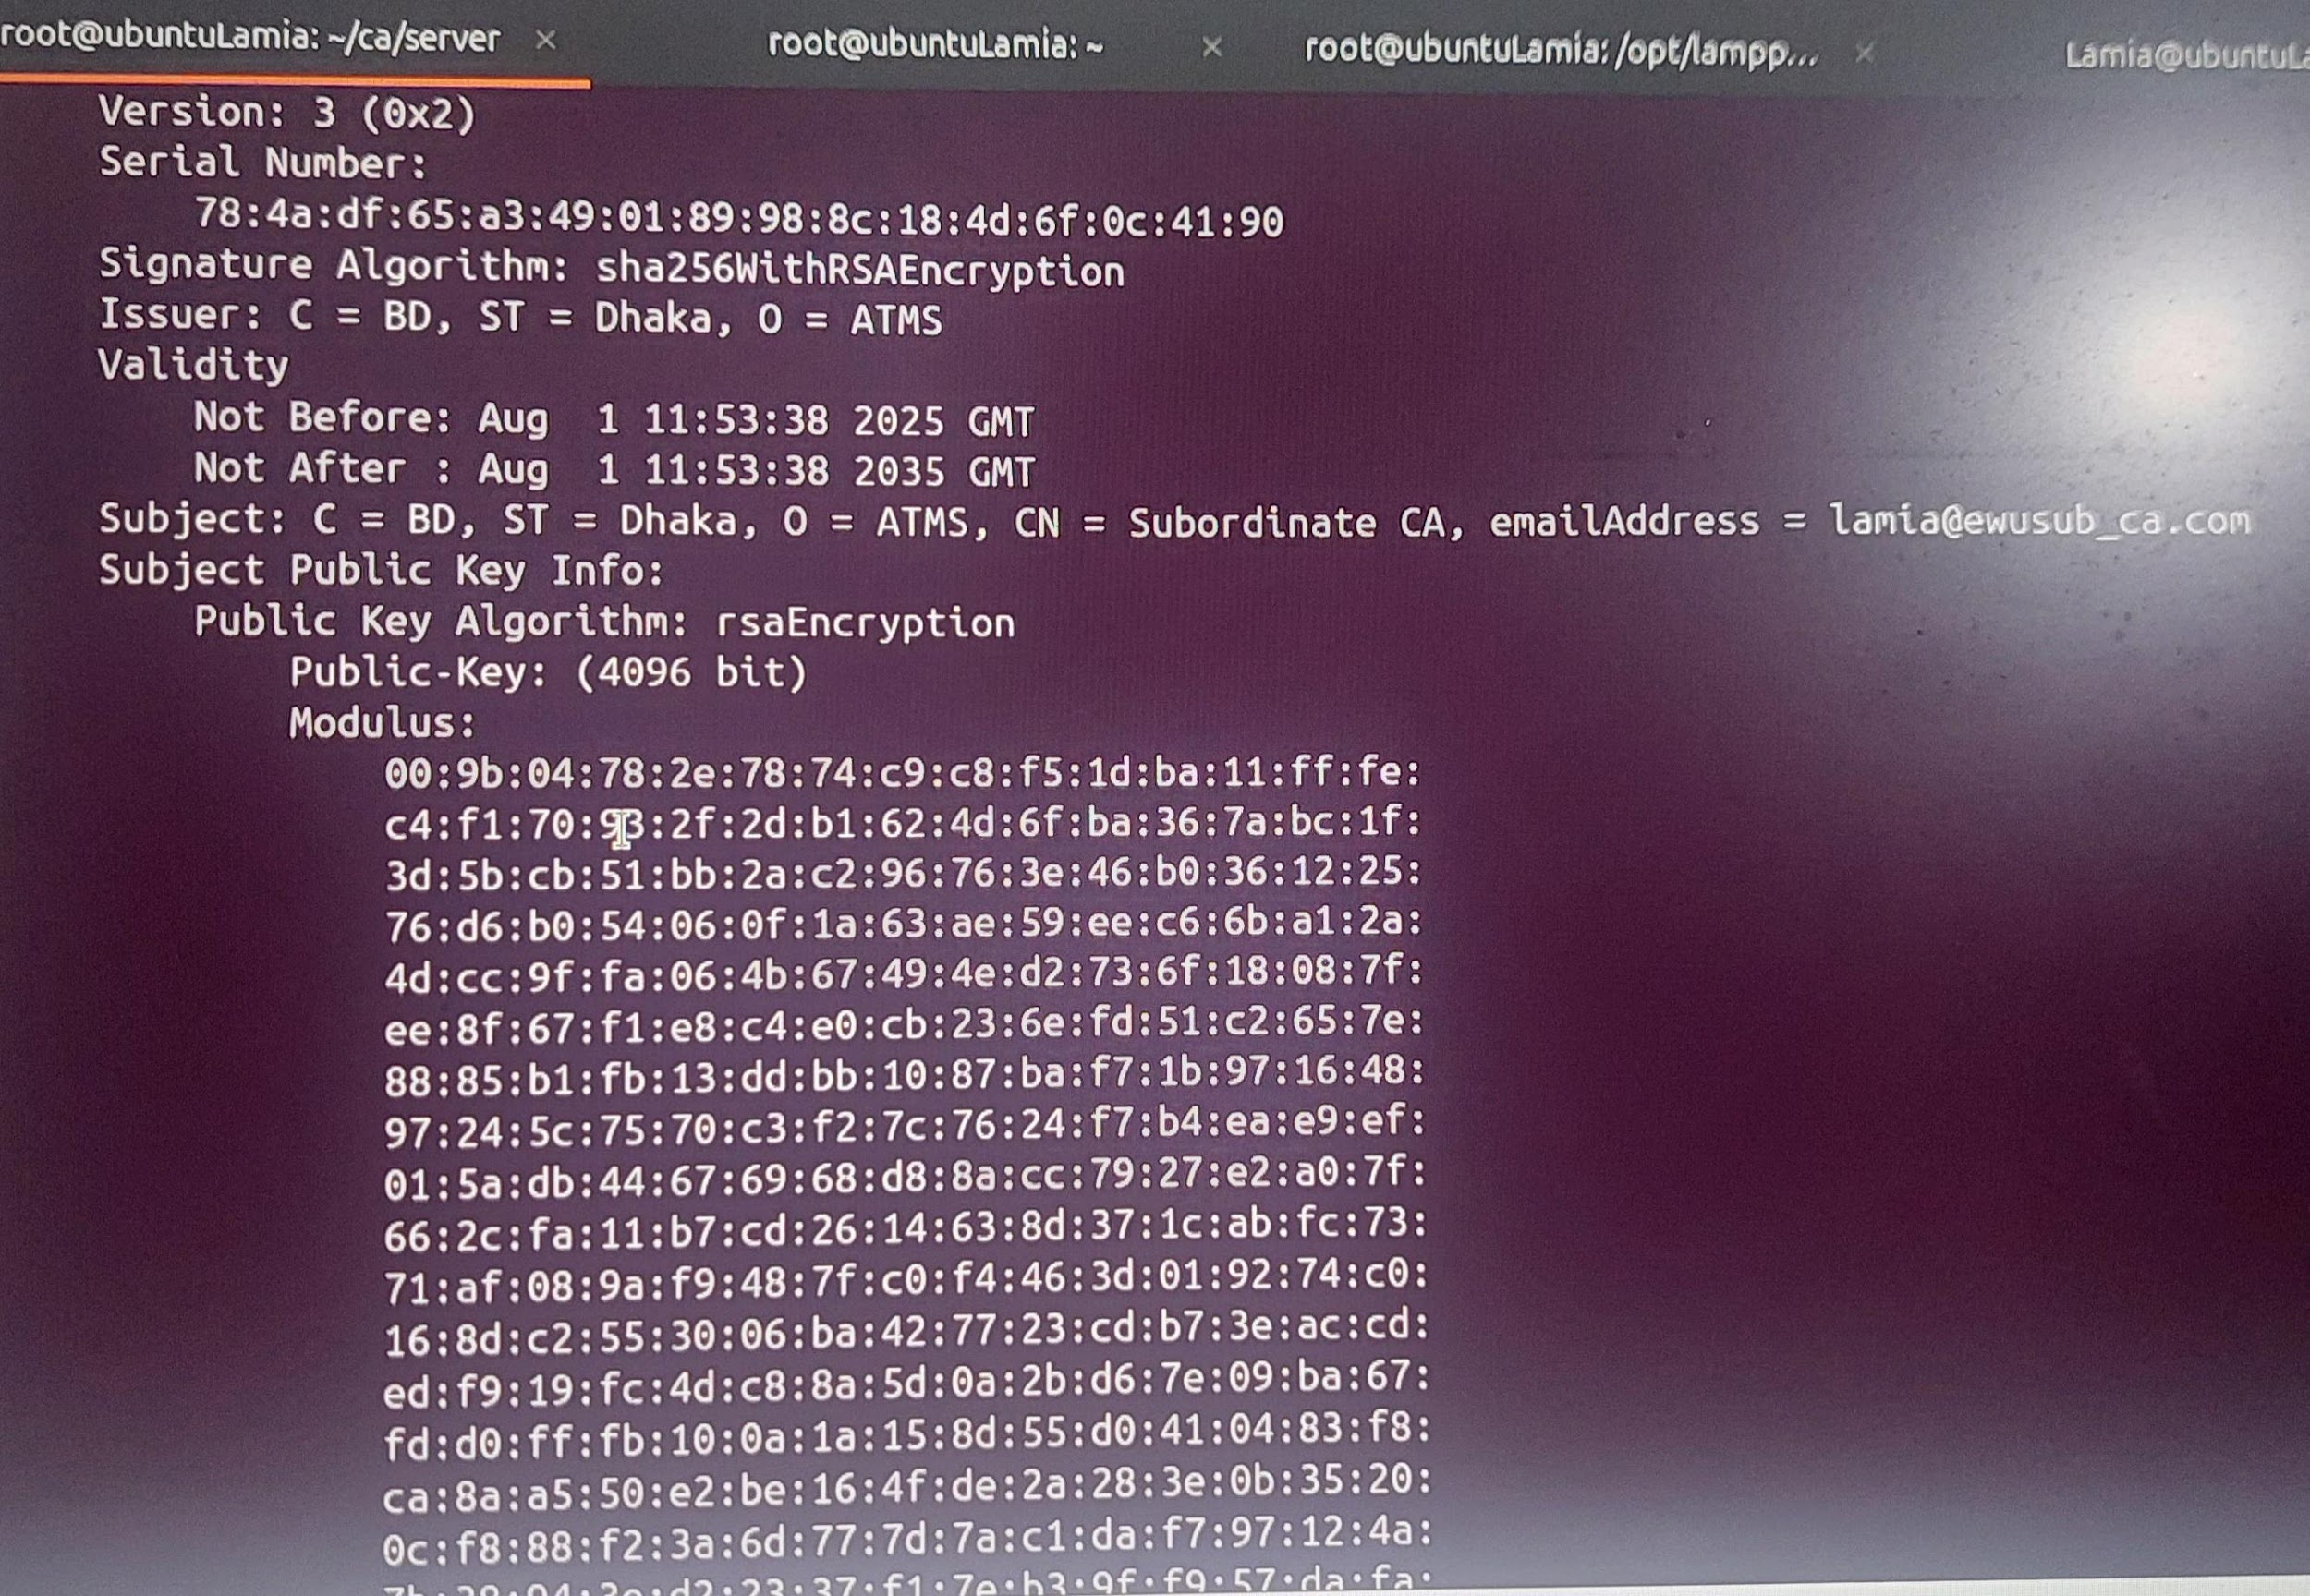

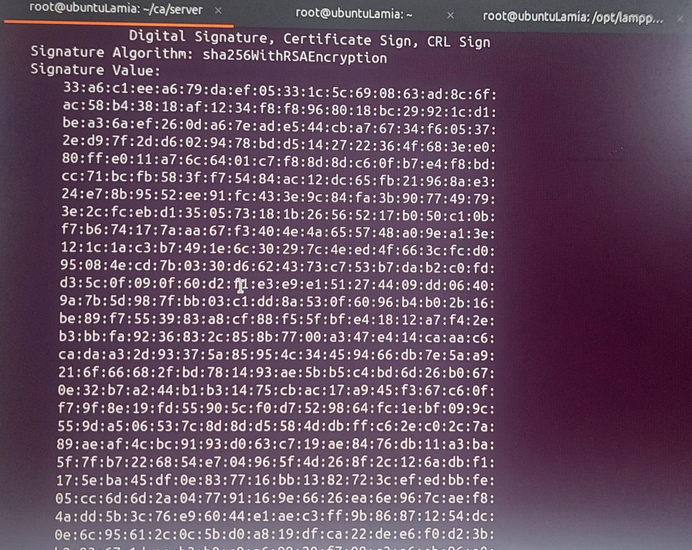

4. Configuring server

* Moving to server: cd ../server

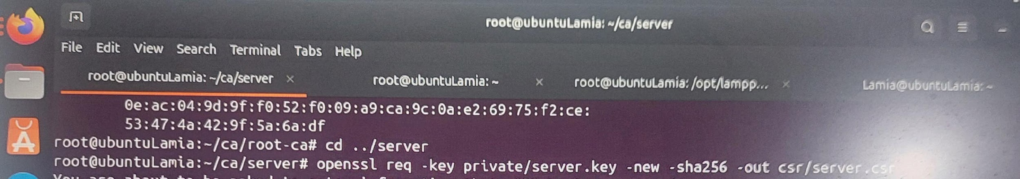

* Generating certificate signing request from server: openssl req -key private/server.key -new -sha256 -out csr/server

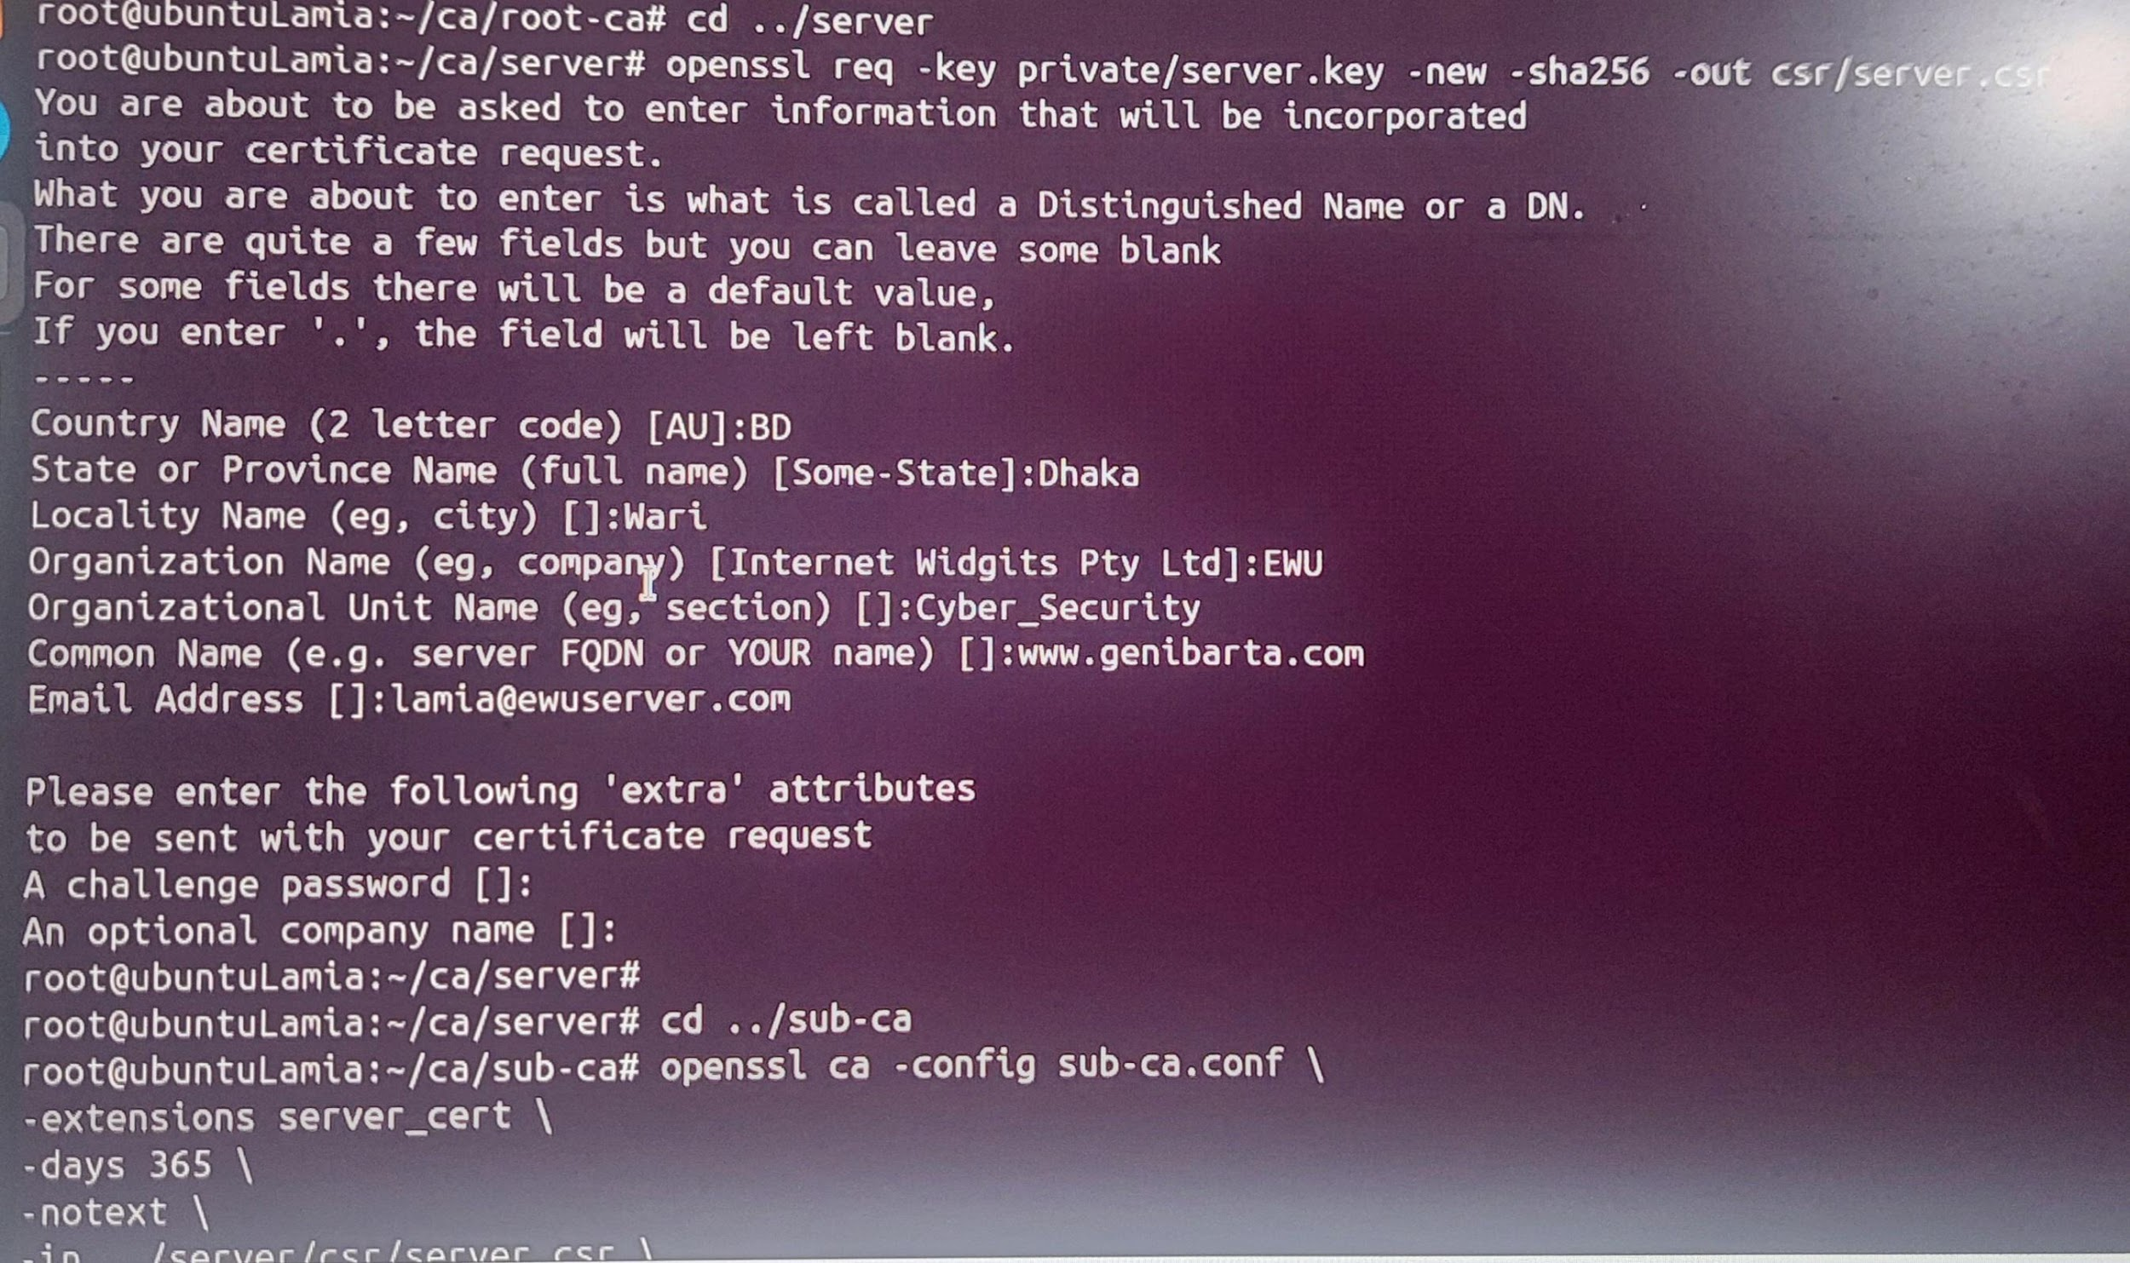

* Sub ca signing certificate request of server: openssl ca -config sub-ca.conf -extensions server_cert -days 365 -notext -in ../server/csr/server.csr -out ../server/certs/server.crt

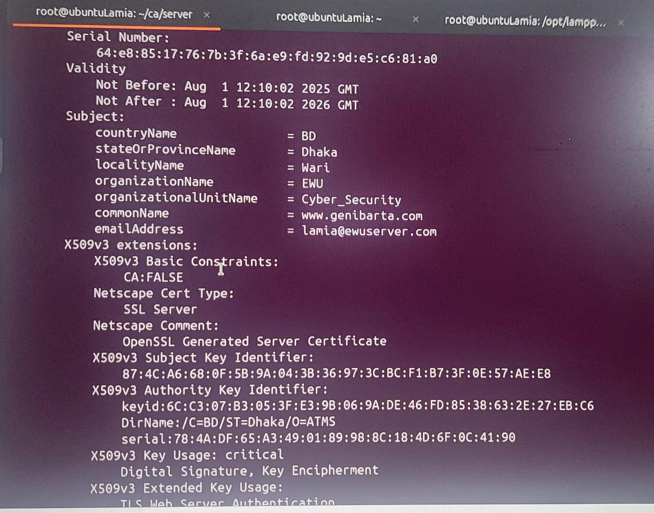

* Seeing Detail: cat index
* moving to certs folder to see certificate of server: cd ../server/certs/
* See the directory by using command: ls
* Now, concating sub-ca.crt and server.crt and naming the new file chained.crt: cat server.crt ../../sub-ca/certs/sub-ca.crt > chained.crt
* Seeing the change: ls
* moving back to server directory: cd ..
* echo "127.0.0.2 www.verysecureserver.com" >> /etc/hosts
* ping www.verysecureserver.com

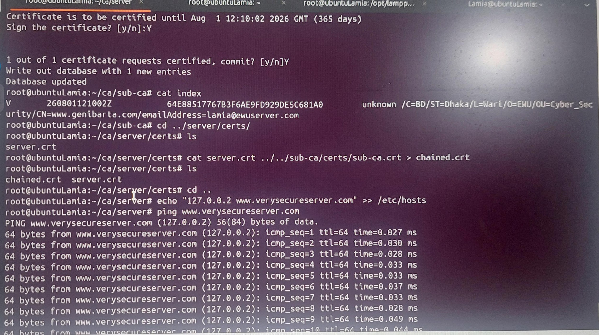

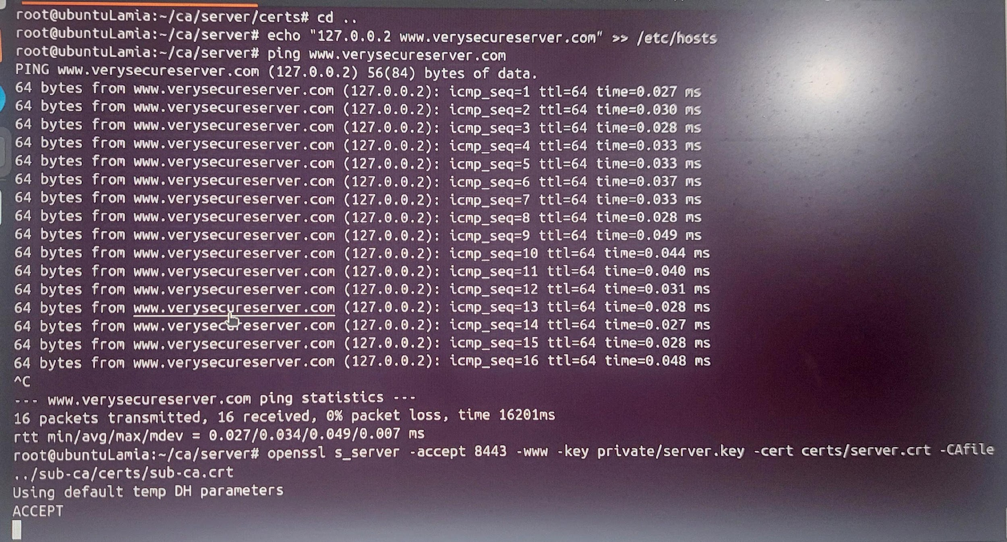

* Turning on the ssl port: openssl s_server -accept 443 -www -key private/server.key -cert certs/server.crt -CAfile ../sub-ca/certs/sub-ca.c genening new terminal

Again to root: sudo -i

See the port number used by different Ip addresses: ss -ntl

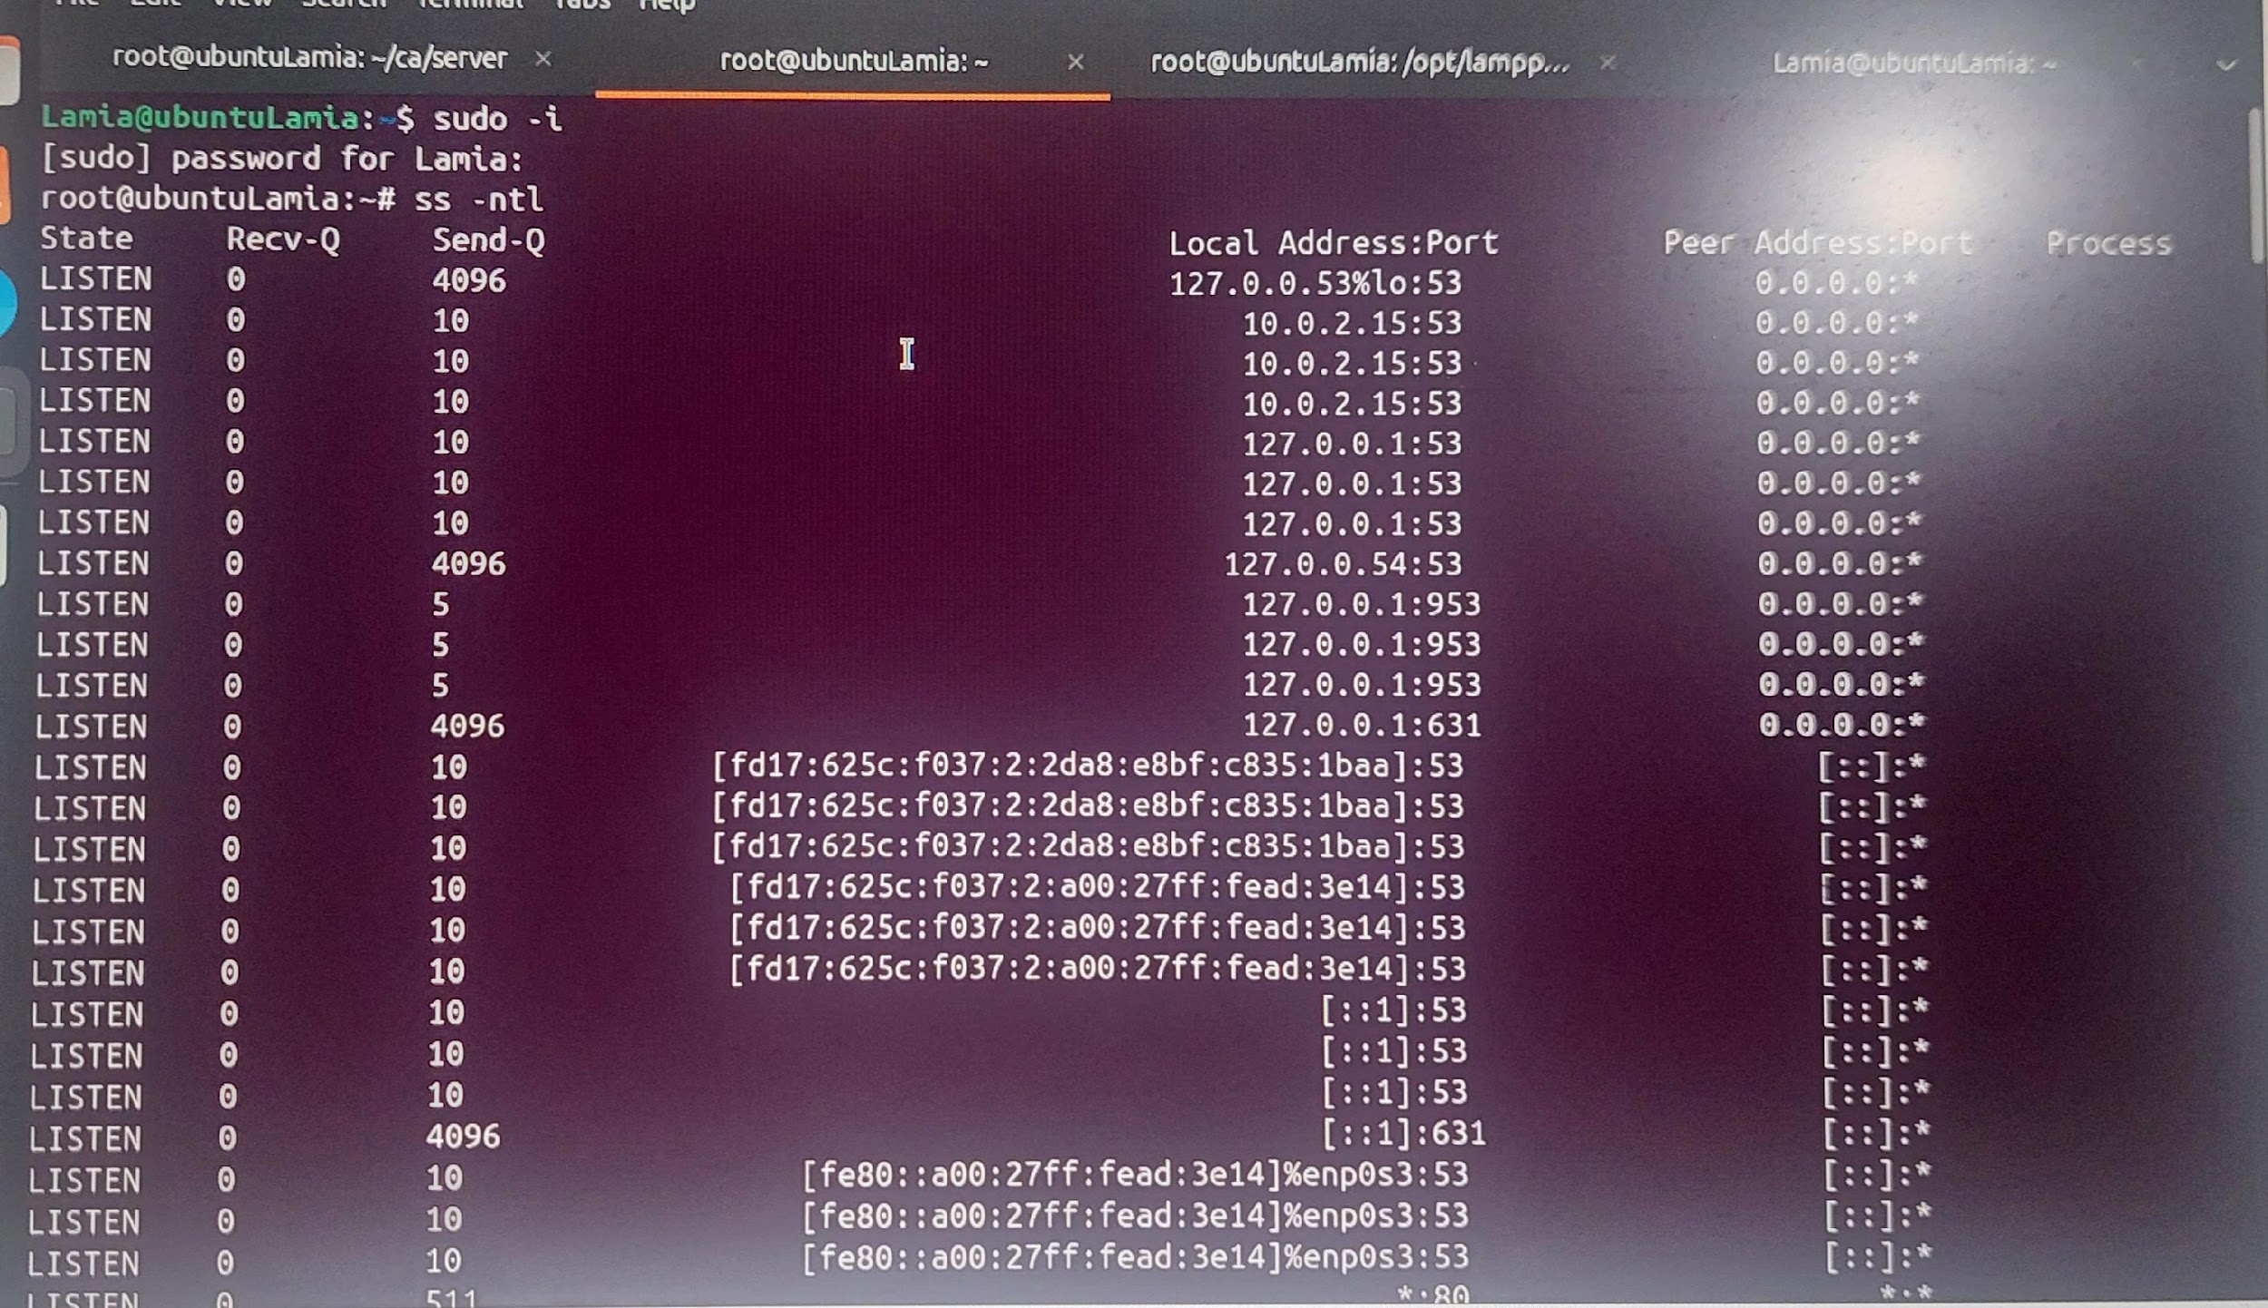

* copying the certificate to ca certificate folder: cp ca/root-ca/certs/ca.crt /usr/local/share/ca-certificates/

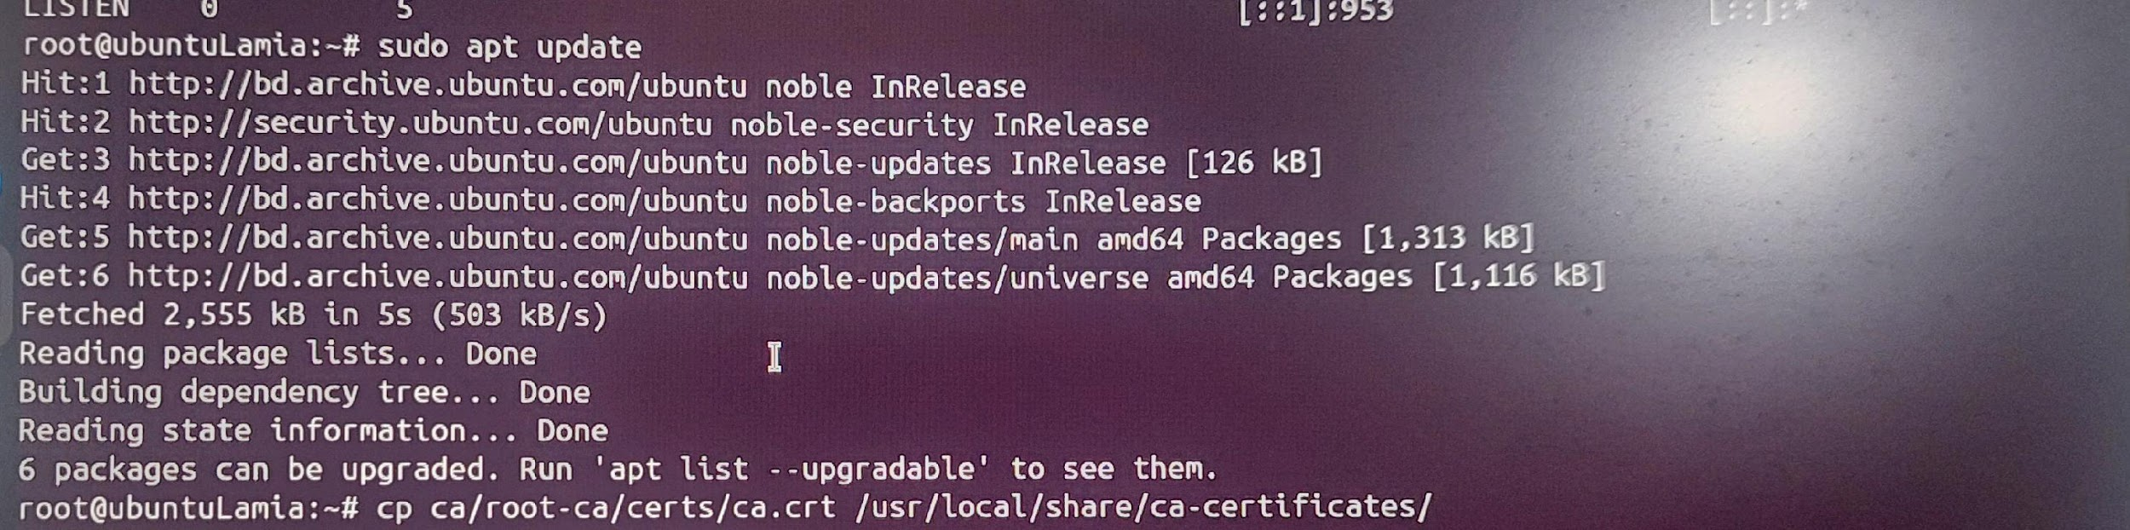

* Updating ca certificate folder: update-ca-certificates -v

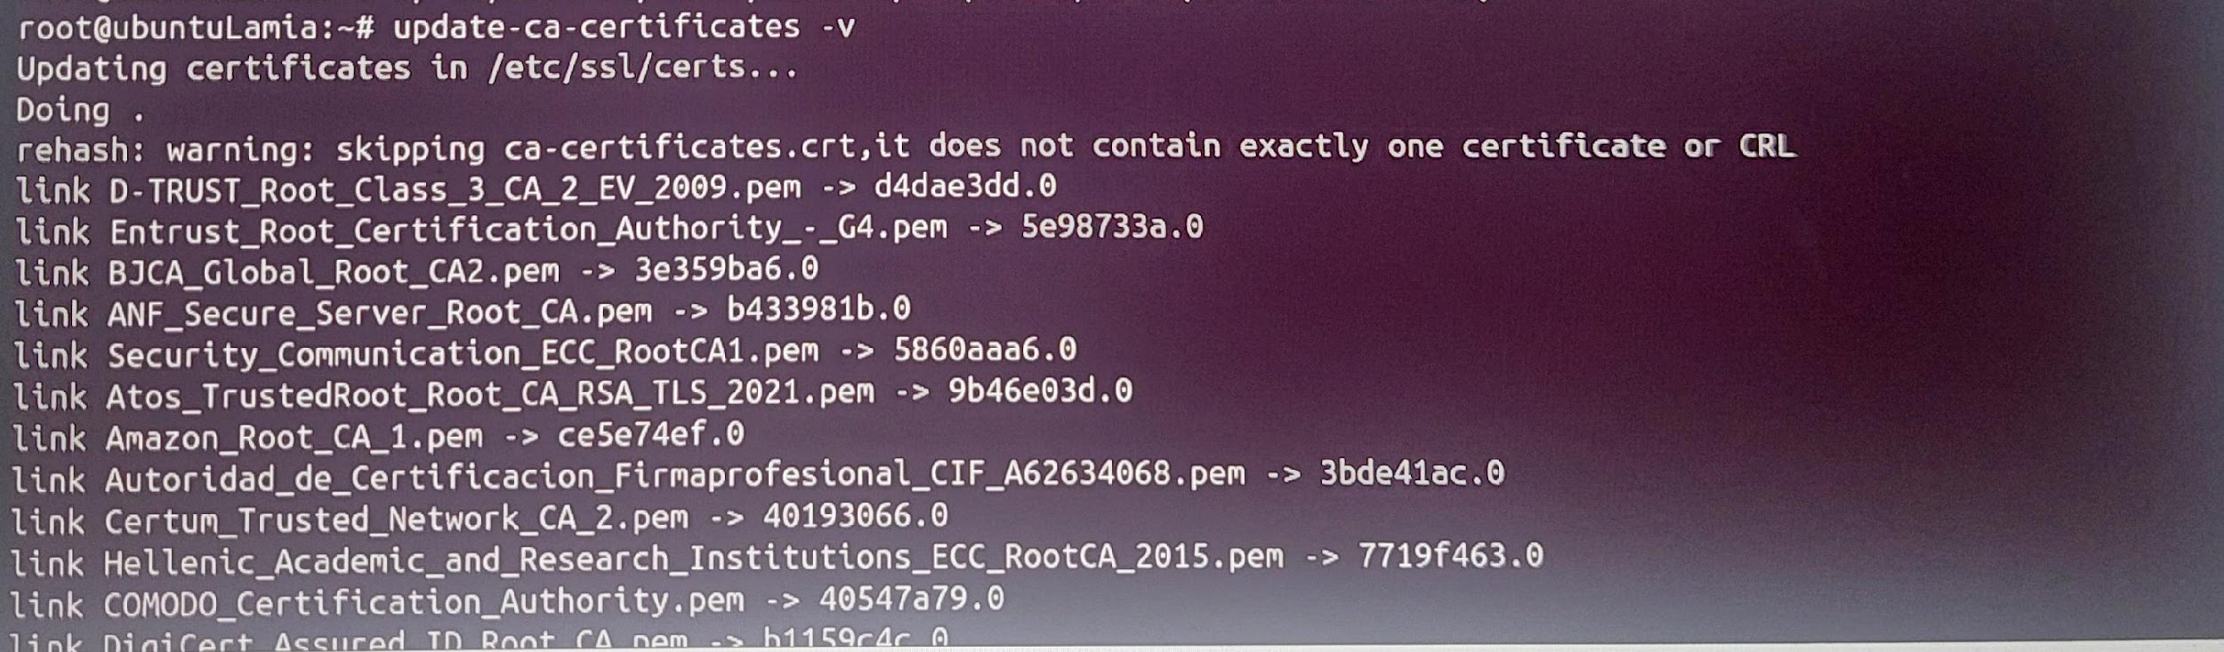

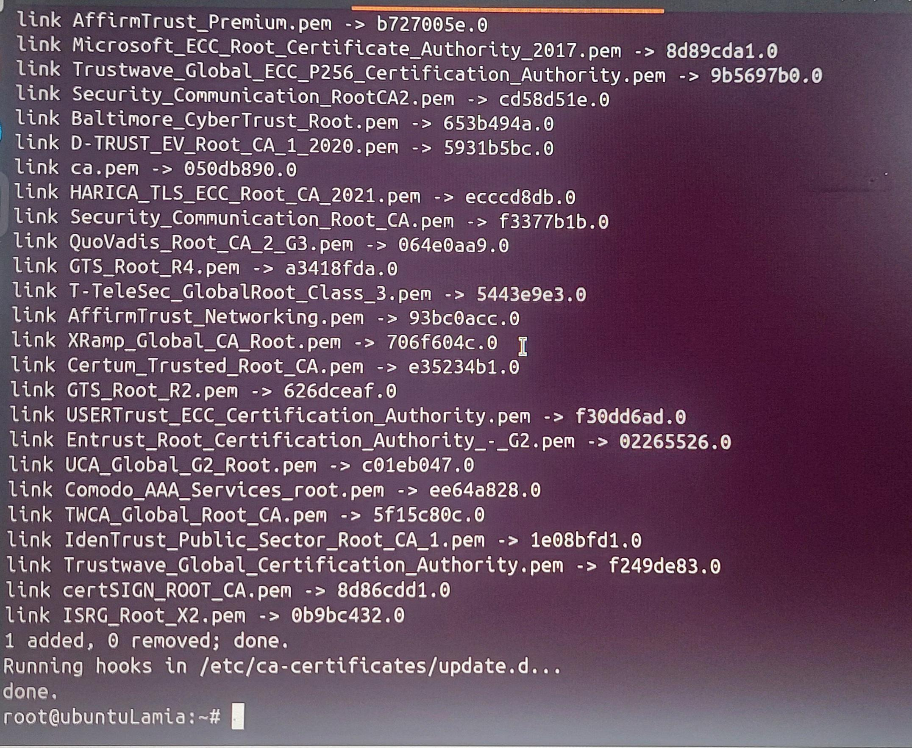

* Open new terminal

sudo -i

tree ca

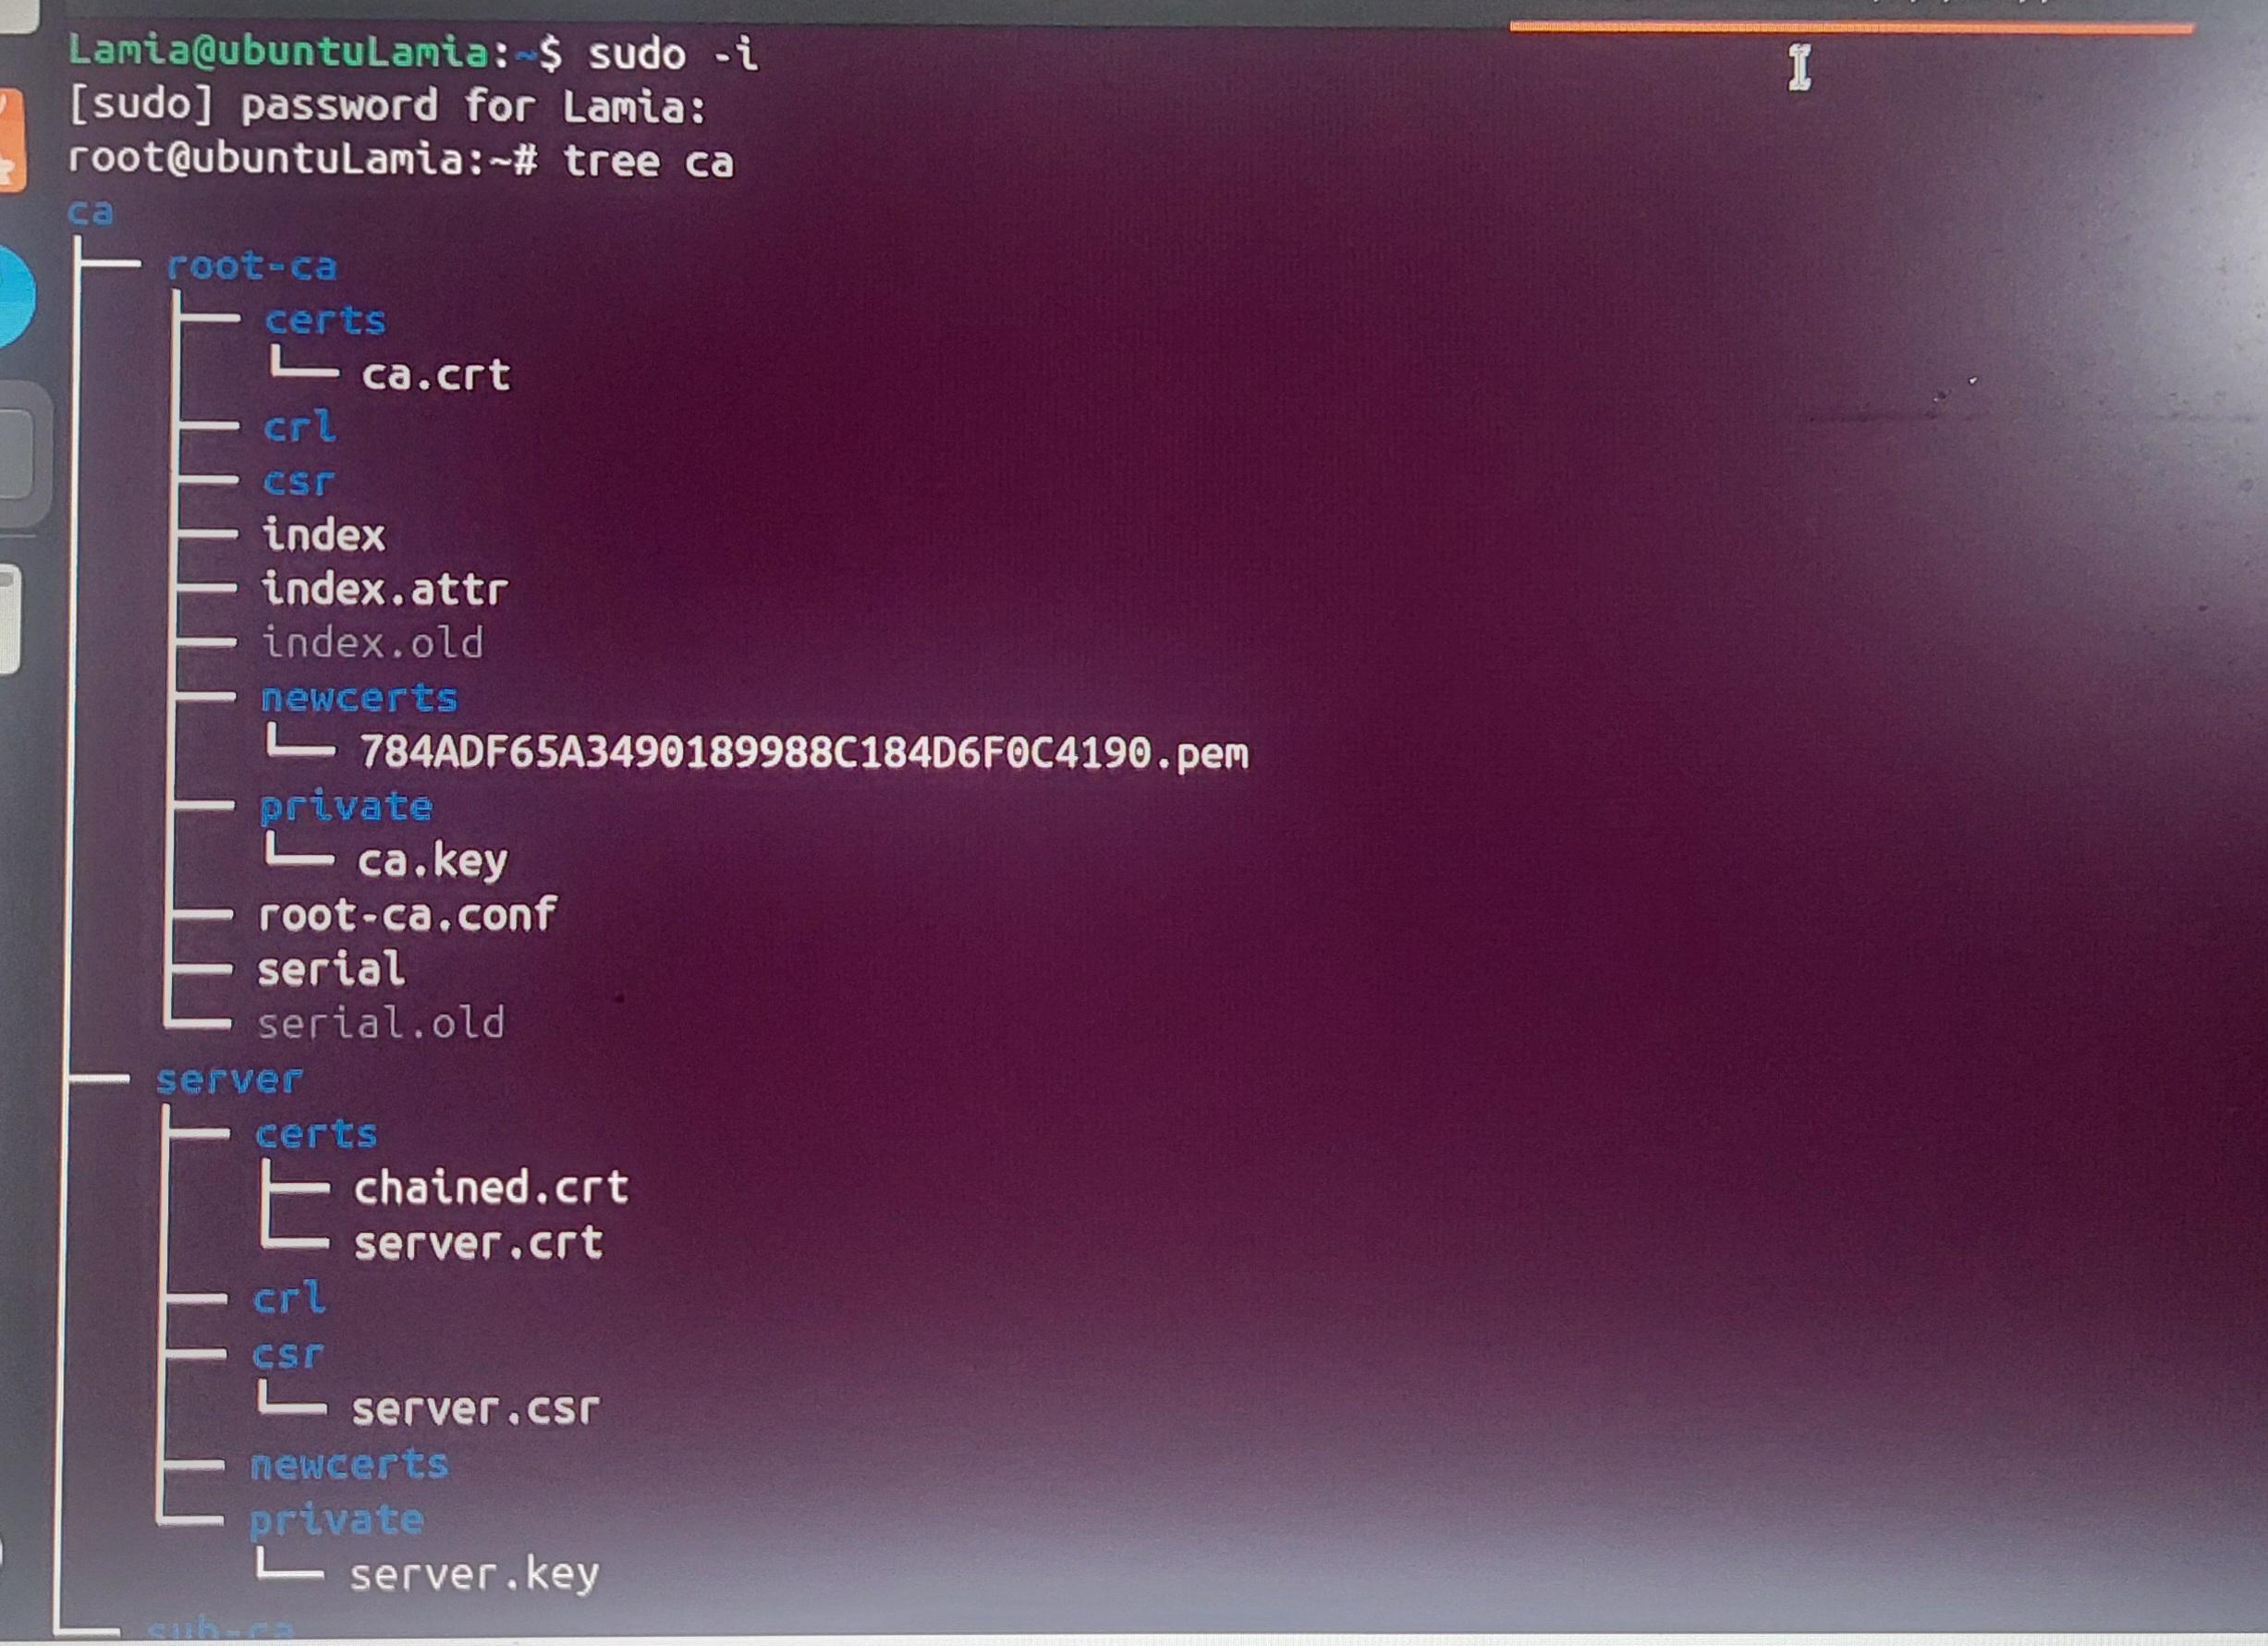

* Finally copy to newcerts directory

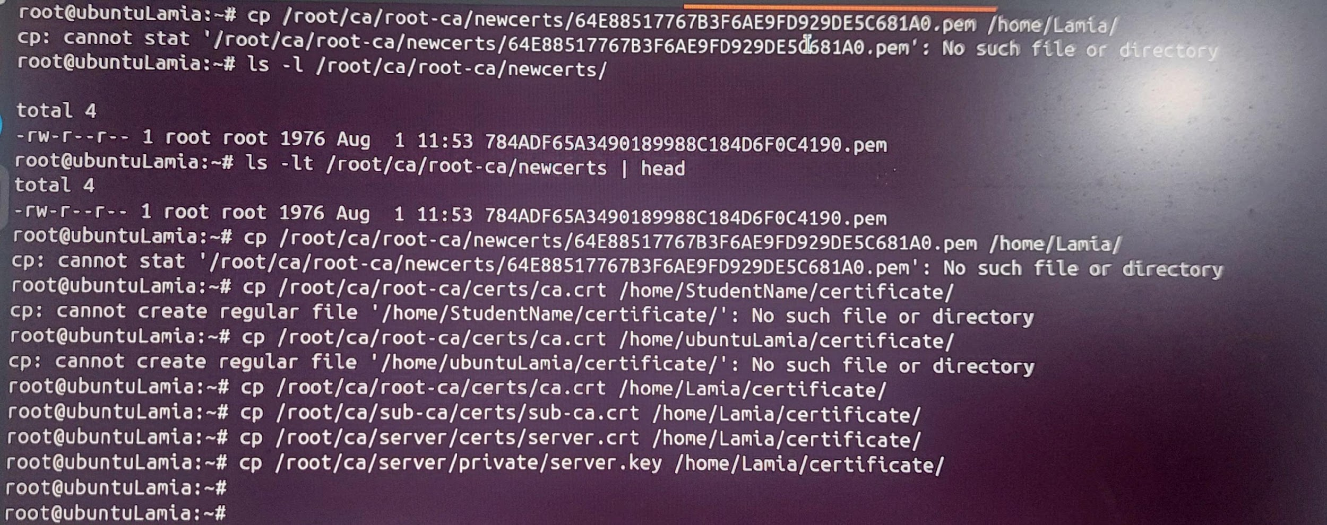

Setup Xampp:

|  |  |
| --- | --- |

* Next go to this location

sudo -i

cd /opt/lampp/etc/extra

chmod 777 httpd-ssl.conf

gedit httpd-ssl.conf

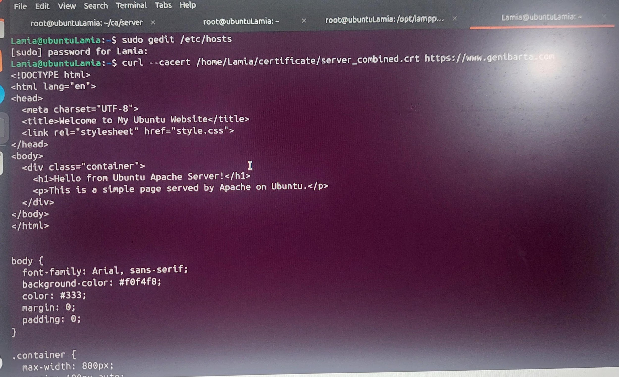

change server.crt location with your server.crt file location

{106 SSLCertificateFile "/home/decoder/certificate/server.crt"}

change server.key location with your server.key file location

{116 SSLCertificateKeyFile "/home/decoder/certificate/server.key"}

change full line with your location

{136 SSLCACertificatePath "/home/decoder/certificate"}

Now we have to remove all file from htdocs

* Go to htdocs: cd /opt/lampp/htdocs
* See htdocs: ls
* Removing folders: rm -r dashboard img webalizer

      rm applications.html  bitnami.css  favicon.ico  index.php

* Now make a html file and write some html code:   touch index.html

         gedit index.html

* Now on the browser

Settings → privacy and security → view certificate → authorities → import → select the file→open → select purpose → {view: to see the certificate} → OK

The Certificate:

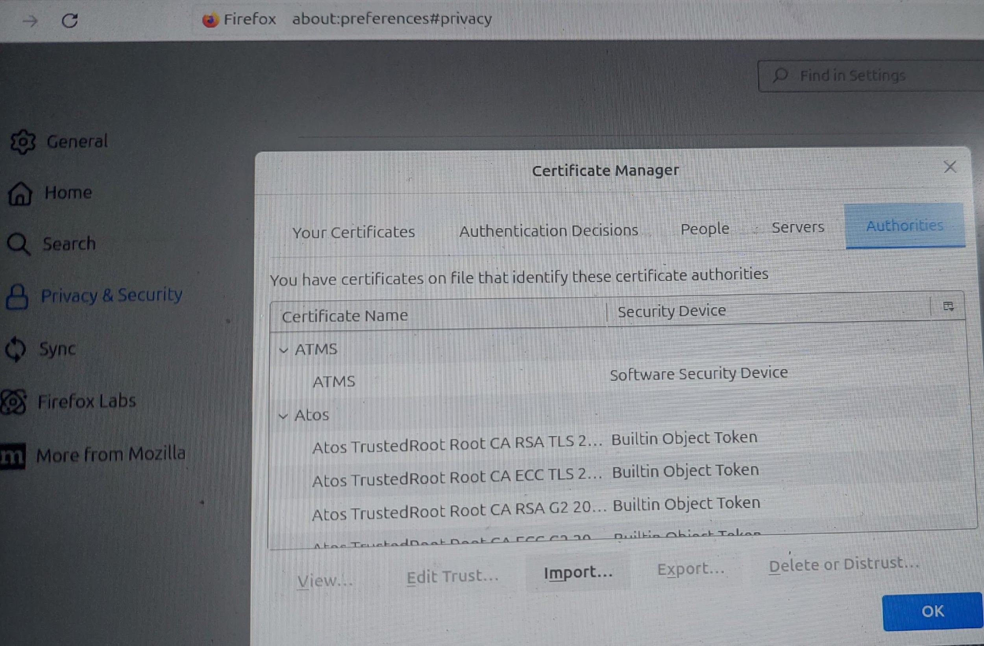

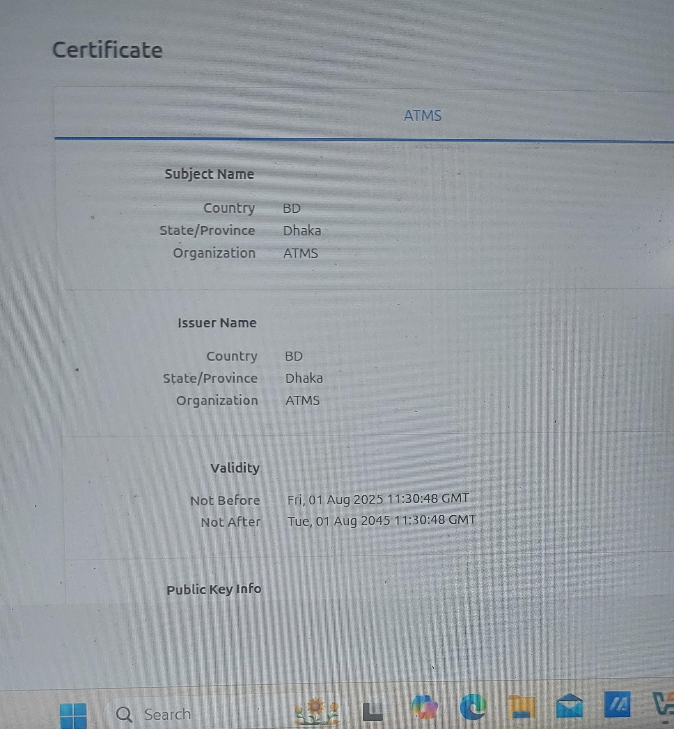

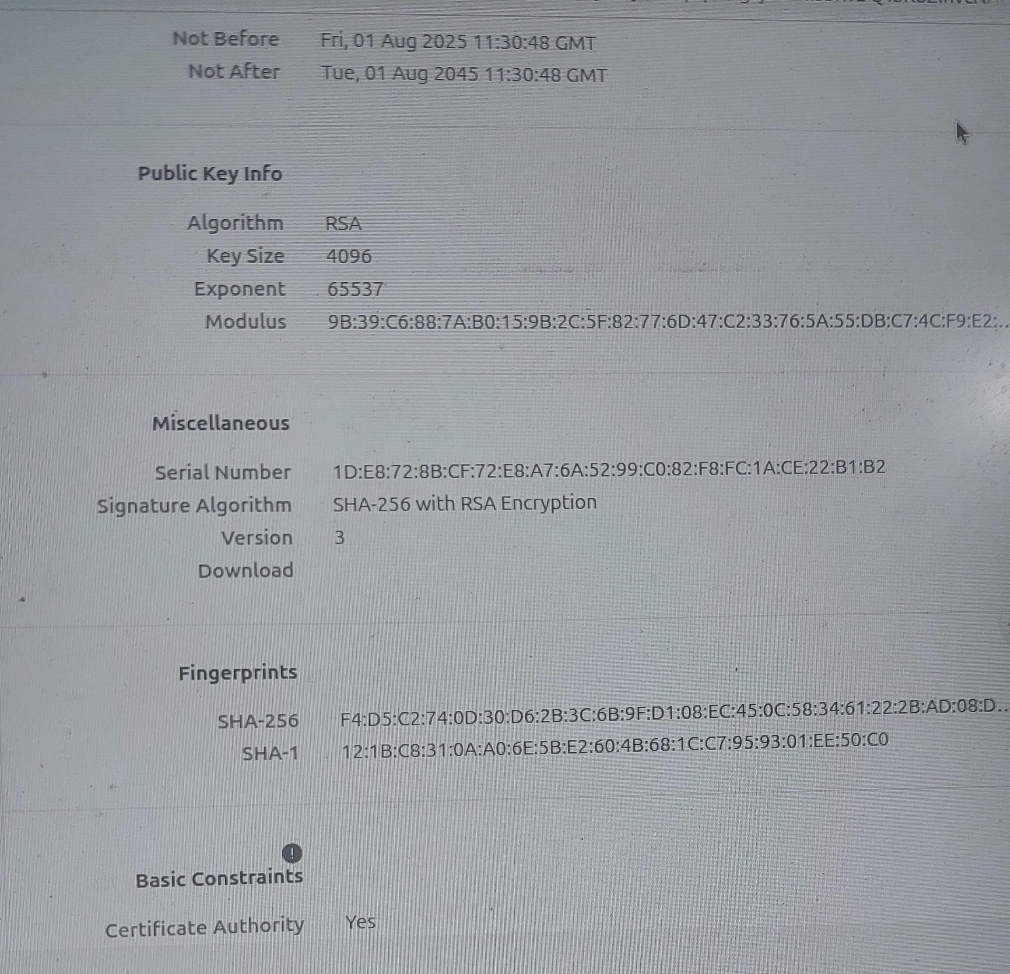

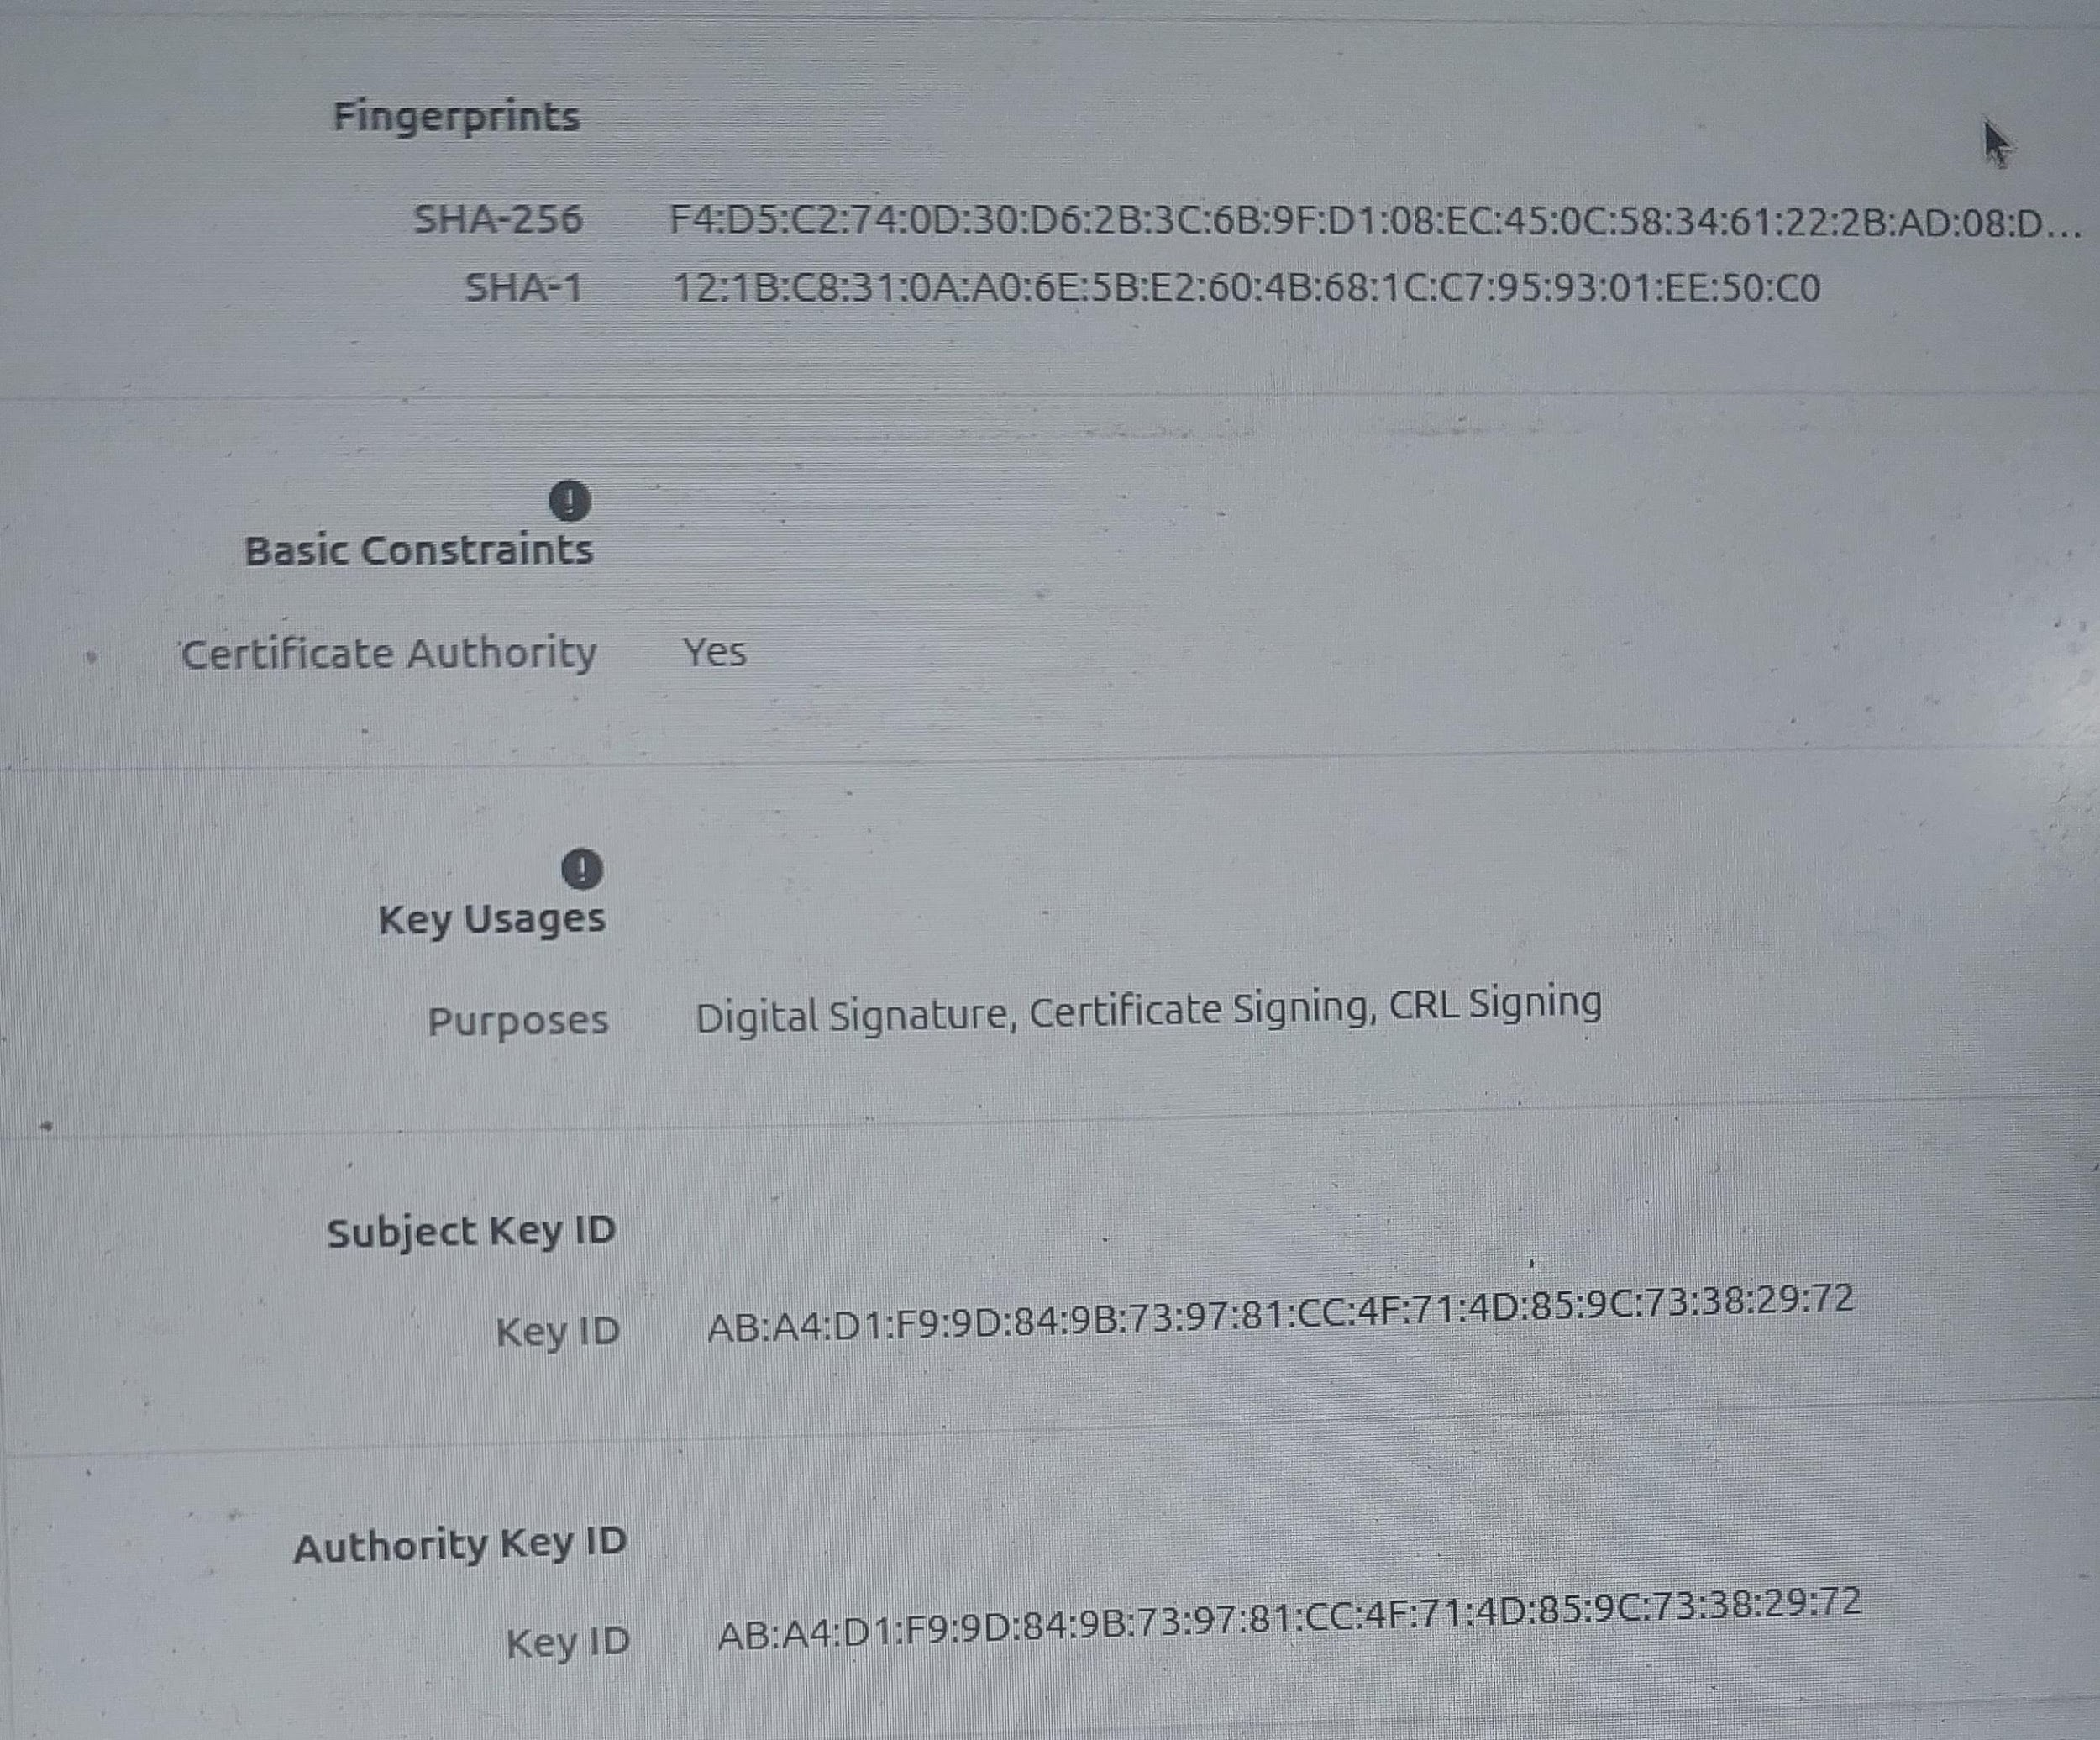

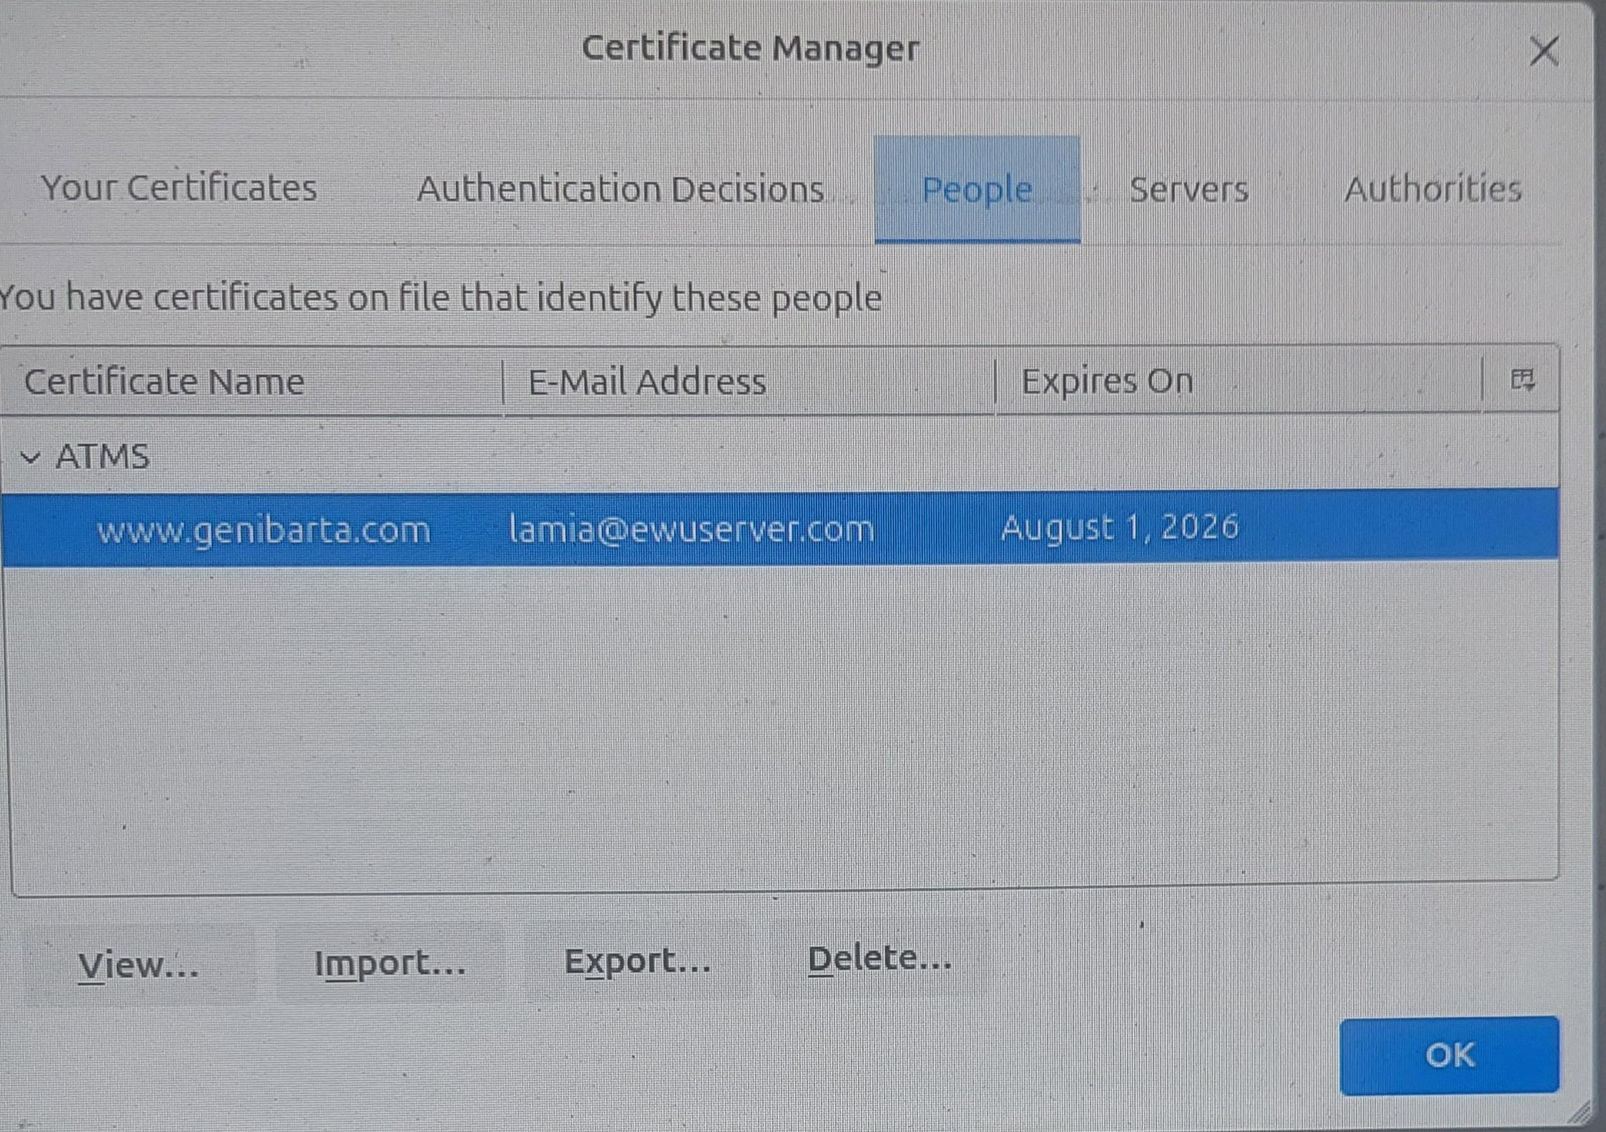

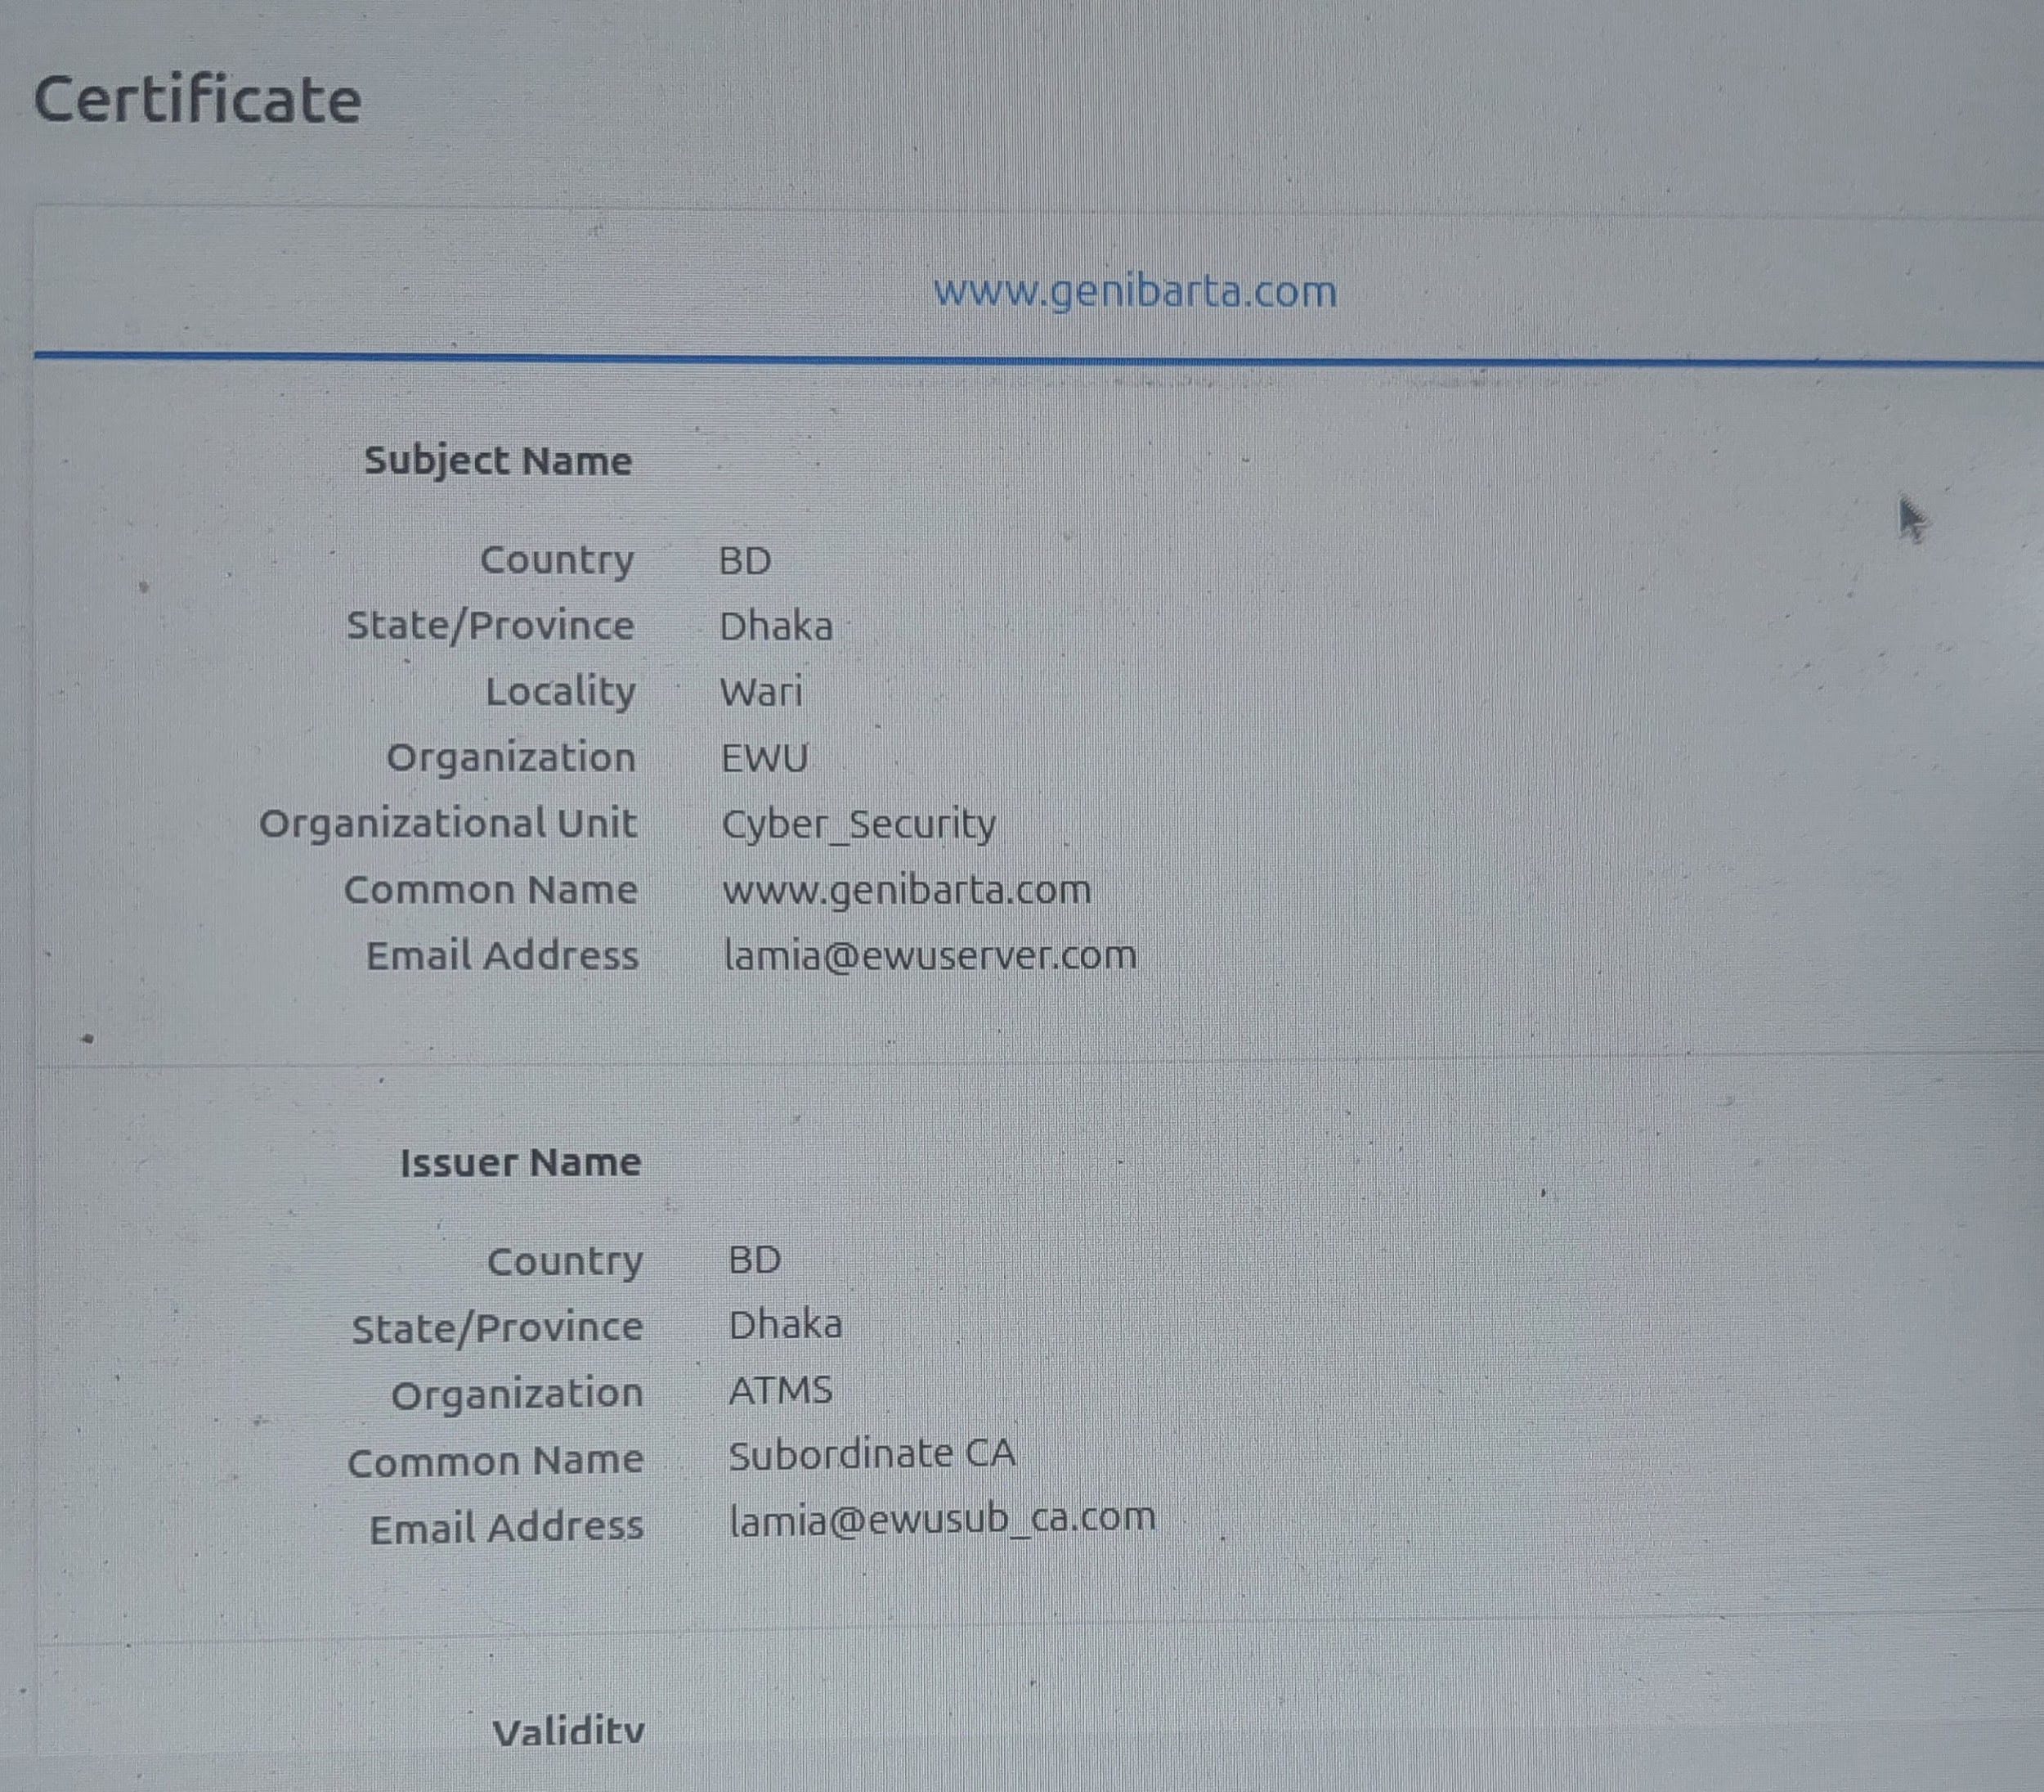

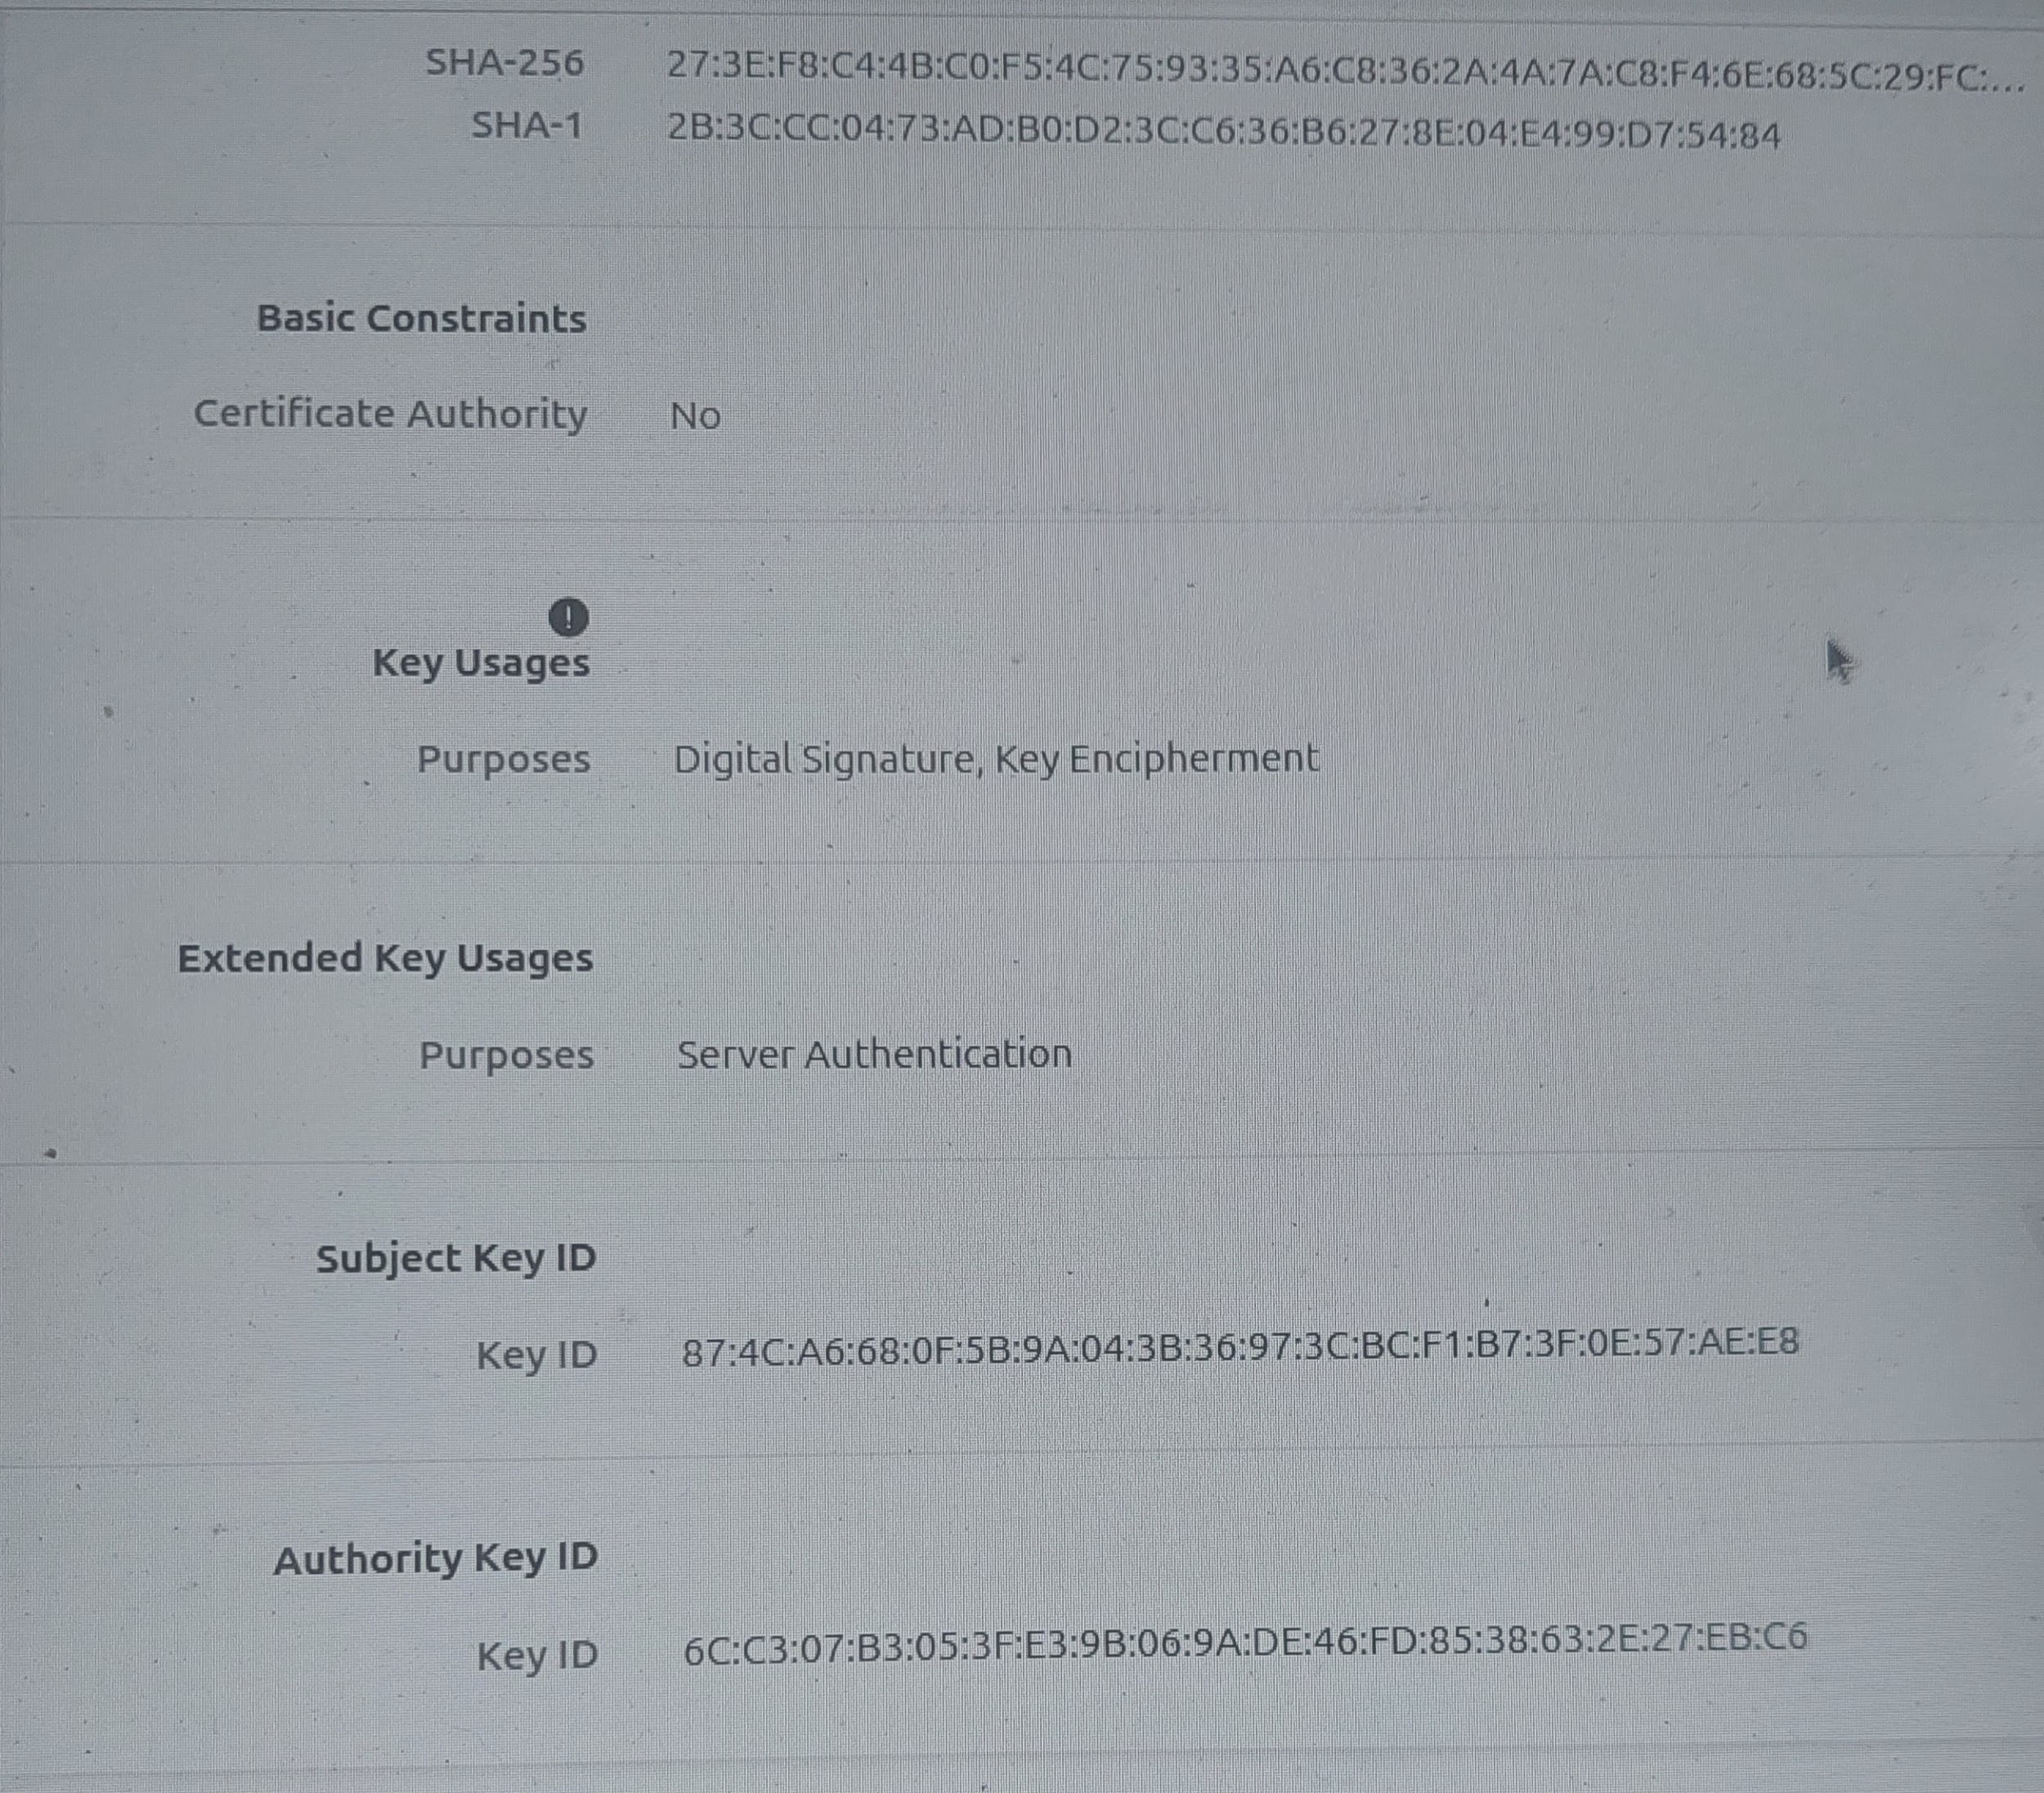

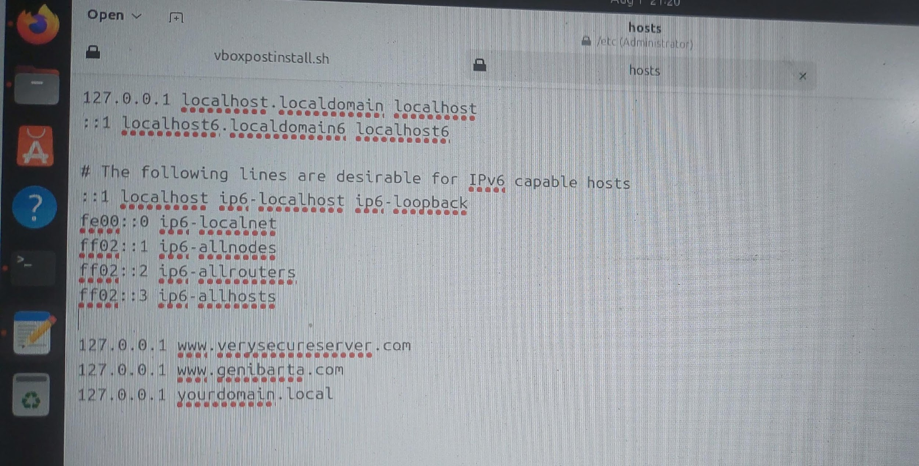

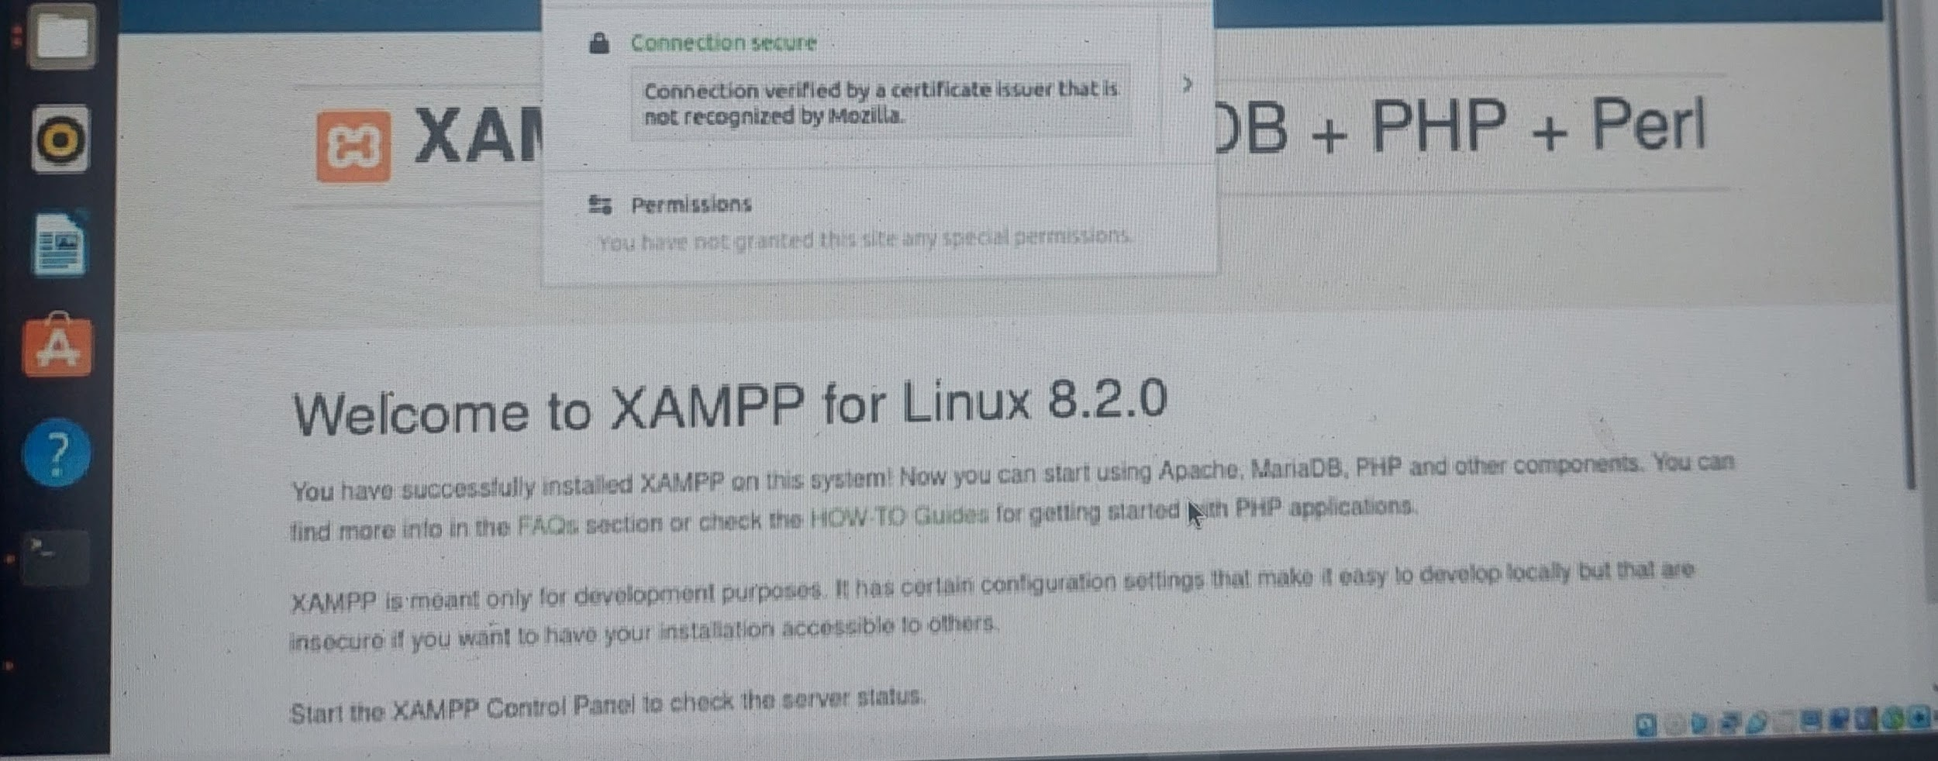

**CONCLUSION**

This project successfully demonstrated the implementation of PKI and TLS to enhance website security. By leveraging digital certificates and encrypted communication protocols, we achieved secure data transmission, authentication, and user trust.

**Recommendations:**

* Regularly update and renew certificates to prevent expiration vulnerabilities.
* Perform periodic security audits to ensure the TLS configuration remains robust.
* Educate users on identifying secure websites and avoiding phishing attacks.
* Explore advanced features such as certificate pinning for additional security.

By continuously investing in secure technologies and practices, websites can build trust with users and safeguard sensitive information in an increasingly interconnected world.